Adam J. Trosclair
July 6, 1935 – March 27, 2006

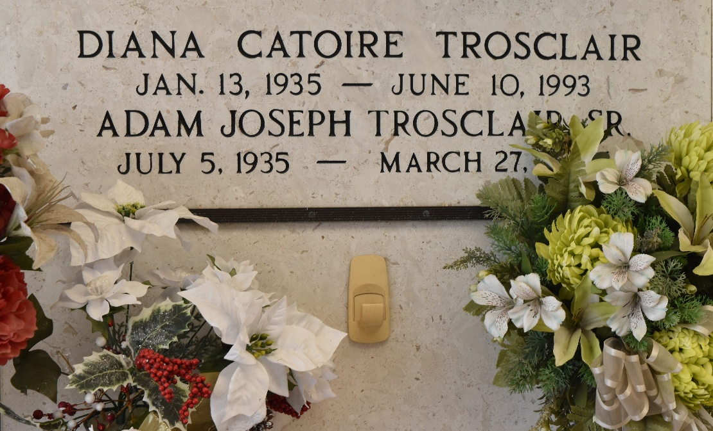

Adam J. Trosclair, Sr. on Monday, March 27, 2006 at 11:40 am.
Beloved husband of the late Diana Catoire Trosclair. Father of Bruce, Adam, Jr. and Roy Trosclair, Staci Trosclair, Teckla Holder, Dee Anne Thomas, Heidi Trosclair and Joetta Matt. Also survived by 15 grandchildren and 11 great-grandchildren.
Son of the late Fred, Sr. and Emma Trosclair. Brother of Eldon and Jim Trosclair, Leda Mae Steib and the late Fred Trosclair, Jr. and Annie Scioneaux. Age 70. A native and resident of Reserve.
Relatives and friends of the family are invited to attend services. Visitation at Millet-Guidry Funeral Home, 2806 W. Airline Hwy., LaPlace on Wednesday, March 29, 2006 from 5:00 pm to 9:00pm and on Thursday from 8am to 9:45am. Followed by religious services at St. Peter Catholic Church Reserve at 10:00 am. Burial in church cemetery.

The Times-Picayune, New Orleans, Louisiana
Mar. 28, 2006

