Berlyne (Williams) Trosclair
August 17, 1953 – July 24, 2022

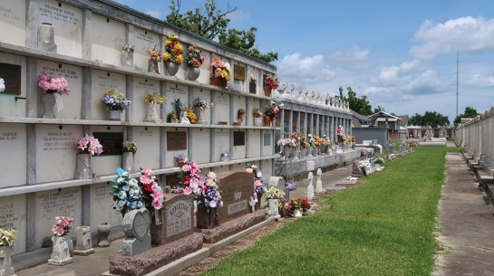

Berlyne Williams Trosclair passed away Sunday, July 24th, 2022. Age 68.
Preceded in death by her parents Sarah Schiro Curtis (Richard), "Boy" Athanas Otere Williams, and her late son Tate Trosclair.
Survived by three of her children Todd Trosclair, Jr., Tasha Trosclair Warren (Benjamin, deceased), Tonia Trosclair Waterfallen (Ryan), and their father Todd Trosclair, Sr. Proud grandmother of Daphne Warren, Tallullah Waterfallen, and Wesley Warren.
A native of New Orleans, raised in Reserve, resident of Destrehan, and a world traveler. She attended Leon Godchaux High School, graduating class 1971, where she was a member of the band, elected most school spirited and class favorite. While working at Toyota, she was recognized as one of their top 50 managers 11 yrs. in a row.
Berlyne lived her life in the service of the Lord, her animal friends, and her community. She was moved to be a part of numerous charities. Any of her spare time was devoted to her family, especially her grandchildren. Beautiful inside and out, she always had a smile on her face and was ready with a hug, laugh, or prayer card for any situation. She will be greatly missed.
Friends are invited for a viewing and to celebrate Mass at St. Peters in Reserve on Monday, August 8, 2022, visitation 9:30 AM with Mass to follow at 11:30AM.

The Times-Picayune, New Orleans, Louisiana
August 4-8, 2022

