Dorothy (LaBauve) Trosclair
November 26, 1930 – August 21, 2015

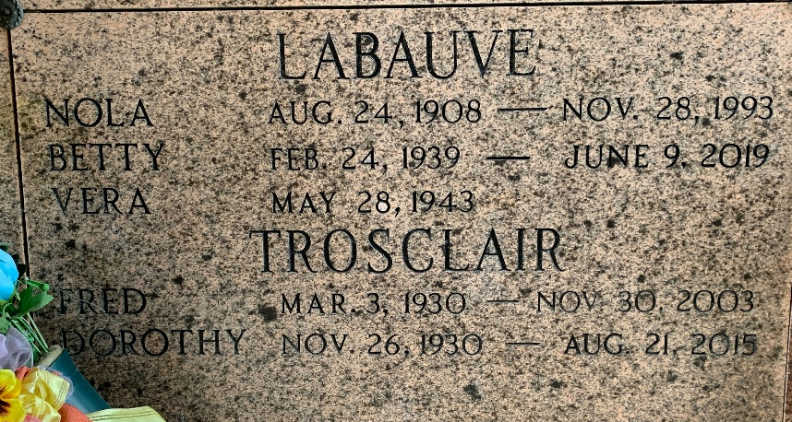
Photo by Team T-Lo

Dorothy LaBauve Trosclair passed away on Friday, August 21, 2015, at the age of 84. She was a native of Garyville, LA, and a resident of Reserve, LA.
Beloved wife of the late Fred Paul Trosclair, Jr. Loving mother of Fred Paul Trosclair, III (Vickie), Cyril Joseph Trosclair (Rose), Ricky Joseph Trosclair (Amy) and Joey Anthony Trosclair (Sandy). Grandmother of Fred Paul Trosclair, IV (Christy), Jason Trosclair, Linnie Paul Ponville (Lisa), Travis Trosclair and Brodie Trosclair. Step grandmother of Michelle Mayfield, Gage Sorapuru, Airel Cooke Reed and Ivan Gould, Jr. Great grandmother of Coby and Robbie Trosclair.
Daughter of the late Joseph Cyril LaBauve and Nola Marie Bourgeois LaBauve. Sister of Elsie Melancon, Beverly Tassin, Betty LaBauve, Vera LaBauve, Ray LaBauve, Linda Ordoyne and the late Shirley Cambre.
Relatives and friends are invited to attend the visitation at Millet-Guidry Funeral Home, 2806 W. Airline Hwy., LaPlace, on Monday, August 24, 2015, from 6:00 p.m. to 9:00 p.m. and on Tuesday, August 25, 2015, at St. Peter Catholic Church, 1550 Hwy. 44, Reserve, from 10:00 a.m. until time of Mass at 11:00 a.m. Interment to follow in St. Peter Cemetery.

The New Orleans Advocate (Louisiana)
Aug. 23 to Aug. 25, 2015

