Ethel Mae (Williams) Trosclair
April 29, 1923 – June 22, 2023

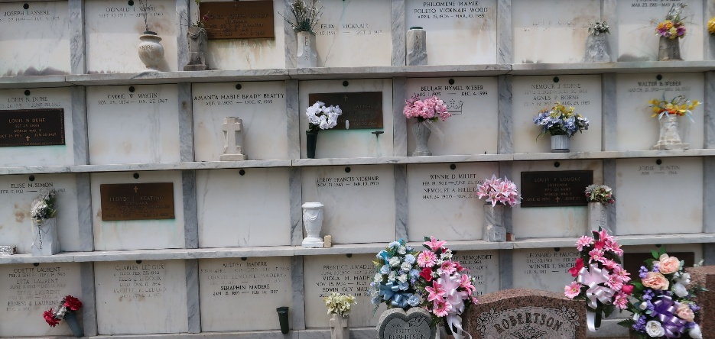

Ethel Mae Williams Trosclair passed away on Thursday, June 22, 2023 at the age of 100. She was a native of Lyons, LA, a longtime resident of Garyville, LA and a resident of Twin Oaks Nursing Home in LaPlace for the last 8 years. Ethel was a member of the Catholic Daughters of America Court #1334. She was a parishioner of St. Hubert Catholic Church and a member of their Ladies Altar Society.
Beloved wife of the late Paul Edgar Trosclair, Sr. Loving mother of Darryl P. Trosclair (Cynthia), Wade P. Trosclair (Teresa), Paul E. Trosclair, Jr. (Judy), Sherry T. Welch (Dennis) and Lisa T. Lozano (David). Grandmother of 11 grandchildren, and 21 great-grandchildren.
Daughter of the late John R. Williams and Virginia Montz Williams. Sister of Joyce Graugnard, and preceded in death by 13 siblings. Also survived by many nieces and nephews.
Relatives and friends are invited to attend the Visitation and Funeral Mass at St. Hubert Catholic Church, 176 Anthony F. Monica St., Garyville on Tuesday, June 27, 2023. Visitation will be held at the church from 9:00 a.m. to 11:00 a.m. followed by the Funeral Mass at 11:00 a.m. Interment in St. Peter Cemetery, Reserve, LA. In lieu of flowers, Masses preferred. Arrange-ments by Millet-Guidry Funeral Home.

The Times-Picayune, New Orleans, Louisiana
June 23-24, 2023

