Mark Trosclair
September 7, 1949 – September 22, 2022

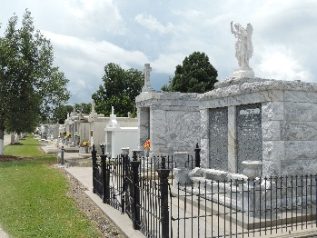

Mark "Tros" Trosclair passed away on Thursday, September 22, 2022 at the age of 73.
Beloved husband of Ellen Granier Trosclair for 38 years of marriage. Loving father of Tara Walthers (Britt) and Rachel Vicknair (John). Loving grandfather of Creed Walthers & Layla and Logan Vicknair, to whom he was affection-ately known as "Pards." Loving brother of Brenda Capaci (Drea) and Beth Mares. Loving brother-in-law of John Granier (Jill) and David Granier. Mark is also survived by a number of nieces and nephews.
Mark was preceded in death by his parents Sylvain and Theresa Trosclair, as well as his brother Dale Trosclair and brother-in-law Dave Mares.
Mark was a graduate from Holy Cross High School and University of Louisiana of Lafayette. Mark was inducted into the University of Louisiana of Lafayette Hall of Fame for Excellence in Baseball. Mark retired from Shell Oil Company in Norco. Mark was an avid golfer and cherished every moment he spent with his family.
Family and friends are invited to attend a Funeral Mass at St. Joan of Arc Church, 529 W. 5th Street, Laplace, LA on Saturday, October 1, 2022 at 12:00 pm. Visitation for family will be at 10:00 am and public visitation will be at 10:30 am. Interment will be at St. Peters Cemetery, Cemetery Road, Reserve, LA 70084, following the Mass.
In lieu of flowers, the family respectfully requests donations be made to the Ochsner Foundation http://ochsner.org/mark.

The Times-Picayune, New Orleans, Louisiana
September 29, 2022

