Richard Joseph Trosclair Sr.
October 5, 1932 – January 21, 2011

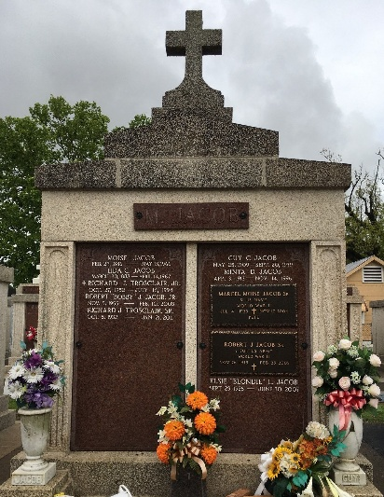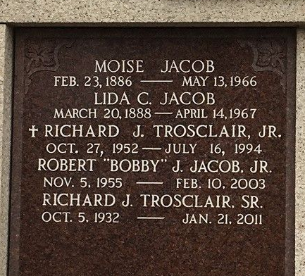
Photo by Team T-Lo

Richard Joseph Trosclair, age 78, died Friday, January 21, 2011 at Ochsner Medical Center in Kenner surrounded by his loving family. Richard was born in Garyville, LA and was a resident of Norco, LA. He provided love and care for his family.
Richard retired from GATX Corp. of Good Hope. He was a faithful member of Sacred Heart of Jesus Catholic Church in Norco, La. He received the Order of St. Louis Medal for service to his church community.
Richard is survived by his loving wife, Shirleen Jacob and his daughters: Kathy Trosclair Lapeyrouse and her husband Ron of Houma, LA, Trudy Trosclair Currier and her husband Ricky of Amite, LA, and Wendy Trosclair Faler and her husband Allen of Charlotte, NC. He loved his grandchildren: Jacob Currier of Amite, LA, and Daniel and Caroline Faler of Charlotte, NC.
Richard was preceded in death by his parents: Folger and Odile Triche Trosclair and by his son, Richard Joseph Trosclair, Jr.
Family and friends are invited to attend visitation from 9:00 a.m. to 11:00 a.m. on Tuesday, January 25, 2011 at Sacred Heart Catholic Church, 401 Spruce Street, Norco, LA. Mass will be celebrated by Fr. Terry Becnel at 11:00 a.m. Burial will be at St. Peters Catholic Cemetery in Reserve, LA.
In lieu of flowers, Masses preferred. Arrangements by Millet-Guidry Funeral Home in LaPlace, LA; (985) 536-7700.

The Times-Picayune, New Orleans, Louisiana
January 23, 2011

