Rose (Hymel) Trosclair
July 23, 1920 – May 24, 2011

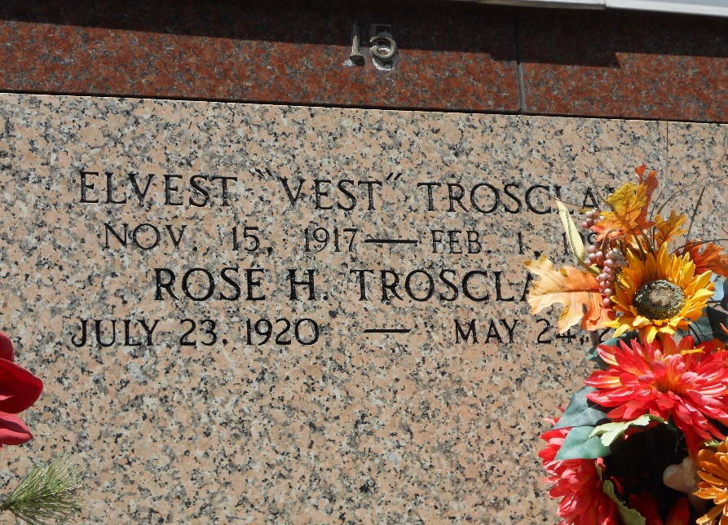
Photo by Team T-Lo

Rose Hymel Trosclair passed away on Tuesday, May 24, 2011.
Beloved wife of the late Elvest Trosclair. Mother of Geraldine Oubre (the late Linden), Gloria Allen (Merlin), Janice Keating (Kenneth) Phyllis Heddings (Gene) and Anna Lee Entremont (Kenneth). Also survived by 15 grandchild-ren, 34 great-grandchildren and 2 great-great-grandchildren.
Daughter of the late Clement and Regina Hymel. Sister of the late Albin, Arnold, Gerard and Clement Hymel and Blandine Williams.
Special thanks to all Care Givers. Age 90. A native of Edgard, La. and a resident of Reserve, La.
Relatives and friends are invited to attend services. Visitation at Millet-Guidry Funeral Home, 2806 W. Airline Hwy., LaPlace, La. on Thursday, May 26, 2011 from 5:00 pm to 8:00 pm and on Friday at St. Peter Catholic Church, Reserve, La. from 8:30 am to 10:00 am, followed by Mass at 10:00 am. Burial in St. Peter Cemetery, Reserve, La.

The Times-Picayune, New Orleans, Louisiana
May 26, 2011

