Shirleen (Jacob) Trosclair
January 30, 1931 – January 24, 2021

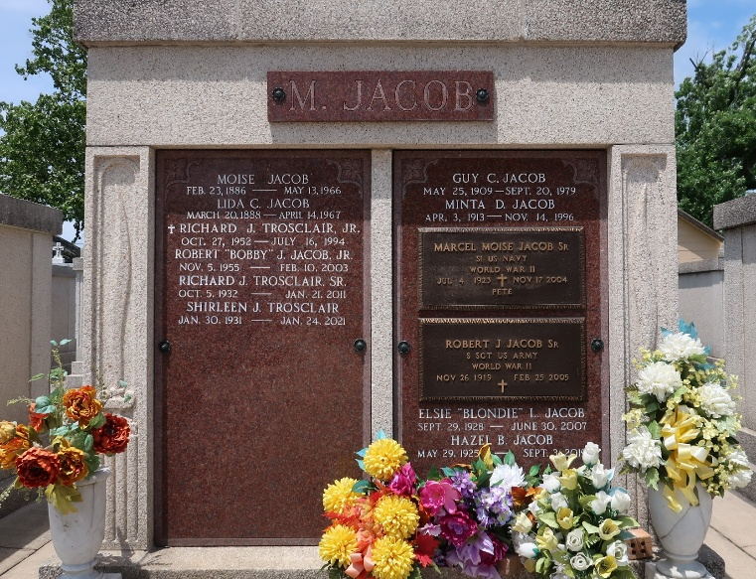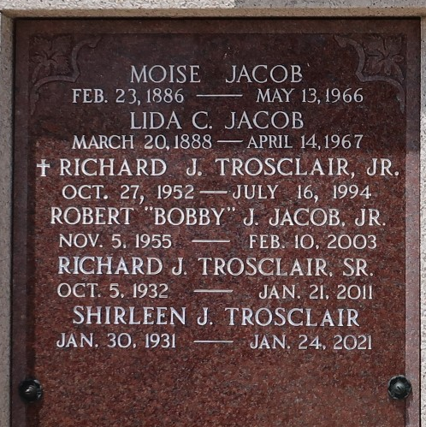

Shirleen Trosclair, beloved wife, mother, sister, aunt, and friend passed to Eternal Life January 24, 2021 in Amite, La. Shirleen was born in Reserve, La. and lived her life in Norco, La after she married her high school sweetheart Richard. They were married for 59 years until his death in 2011.
Shirleen lived a full and joyful life which she shared with her family and friends. As a wife and mother, she was a part of the Sacred Heart Church Community and was involved with many ministries. She gave her heart to Sacred Heart Elementary School and was a lifetime member of the Sacred Heart Altar Society. She cared for many friends in the neighborhood and always visited them with tasty treats. But most of all, she invited many to sit on her swing under the oak tree in her front yard for a chat and visit.
Many blessings came out of those conversations with family and friends. She was cared for and loved the most by her surviving family: Kathy Lapeyrouse of Houma, Trudy and Ricky Currier of Amite, and Wendy and Allen Faler of Charlotte, NC. She lived to share her love and joy with her grandchildren Jacob Currier of Amite and his fiancée Kathryn Teriot, and Daniel and Caroline Faler of Charlotte, NC.
She was preceded in death by her husband Richard and their son Richard Jr., her father and mother Moise and Lida Jacob, her brothers Guy, Allain, Harry, Marcel, Robert, and Leonard Jacob along with her sister Alma Guillot.
A private funeral mass will be celebrated at St. Helena Catholic Church in Amite, La by Fr. Mark Beard. Burial will be at St Peter's Cemetery in Reserve, La.
We ask that all who loved Shirleen pray a Rosary and mass intentions are appreciated. Memorial donations may also be made to Full of Grace, P O Box 1647 Amite, LA. 70422. Harry McNeely & Son Funeral Home, Tangipahoa Parish, Louisiana in charge of arrangements.

The Times-Picayune, New Orleans, Louisiana
January 27, 2021

