Staci A. Trosclair
October 2, 1956 – February 26, 2011

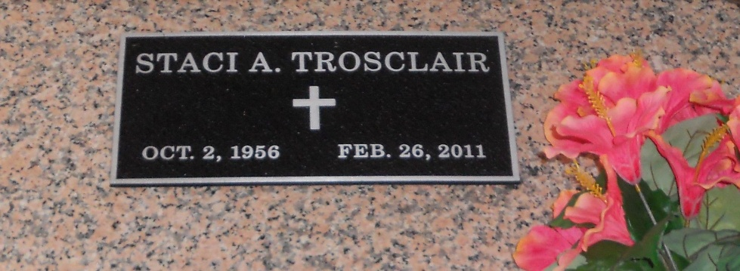
Photo by Team T-Lo

Staci A. Trosclair passed away on Saturday, February 26, 2011.

Beloved fiancé of Kerry (Que) Cambre. Mother of Jonathan and Dianna Hall. Grandmother of Leighton, Grant and Emma Hall, Bryce and Kylee Lipscomb.

Daughter of the late Adam Sr. and Diana Trosclair. Sister of Bruce Sr., Adam Jr., Roy and Heidi Trosclair, Teckla Holder, Dee Anne Thomas and Joetta Matt. Age 54. A native and resident of LaPlace, La.

Relatives and friends are invited to attend services. Visitation at Millet-Guidry Funeral Home, 2806 W. Airline Hwy. LaPlace, La. on Monday, February 28, 2011 from 5:00 pm to 9:00 pm and on Tuesday from 8:00 am to 8:45 am, followed by Mass at St. Peter Catholic Church, Reserve, La. at 9:00 am. Burial in St. Peter Cemetery.

The Times-Picayune, New Orleans, Louisiana
February 27, 2011

