Theresa (Gauthreaux) Trosclair
November 4, 1922 – December 4, 2017

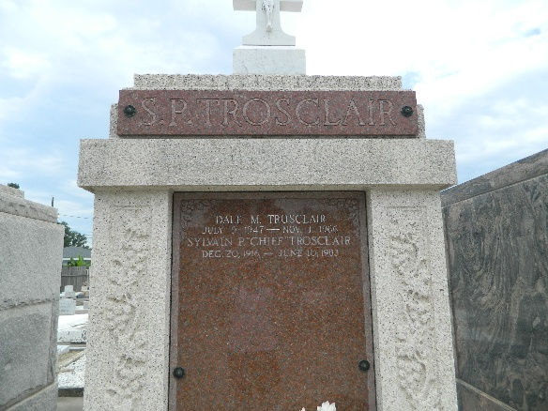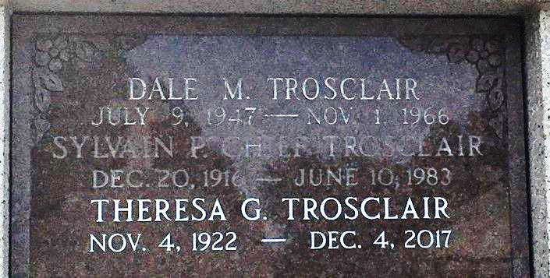
Photo by Team T-Lo

Theresa “Tessie” G. Trosclair, 95, passed away on December 4, 2017. She is reunited in heaven with her loving husband, Sylvain P. Trosclair. Tessie is survived by her children; Brenda Capaci (Drea), Mark Trosclair (Ellen), and Beth Mares (David). Grandchildren: Bruce Pendleton (Angele), Stacy Woodward (Steve), Kyle Capaci (Jennifer), Eric Capaci (Carolann), Brett Capaci (Cindy), Matt Mares (Stephanie), Dusty Mares (Kira), Tara Walthers (Britt), and Rachel Vicknair (John). Great grandchildren: Casey Perelli (Scott), Callie Pendleton, Shayla Woodward, Shane Woodward, Coleman Capaci, Avery Capaci, Matthias Capaci (Susanna), Josiah Capaci (Tiffiny), Ezekiel Capaci, Chloe Capaci, Gloryann Capaci, Lauren Capaci, Hannah Capaci, Reagan Capaci, Maddy Mares, Amelia Mares, Ian Mares, Peyton Mares, Makenzie Mares, Creed Walthers, and Logan Vicknair. She is also survived by three great-great grandchildren Laynie, K.J. and Bentley Capaci.
She is preceded in death by her son Dale Trosclair, siblings Eddie Gauthreaux Jr., Ruby Tregre, J.T. Gauthreaux, Irivin Gauthreaux, and Ethel Mae Breithaupt, and her parents Eddie and Theresa LeBlanc Gauthreaux.
Tessie was the co-chaplain at Touro infirmary for 32 years and a member of the founding board of Magnificat as well as an active member in Sacred Heart ministry.
The family would like to thank the staff of Brookdale Assisted Living for their care and compassion in the past year.
Relatives and friends are invited to Sacred Heart Catholic Church, 401 Spruce St. in Norco, for visitation on Saturday, December 9, 2017 beginning at 9:15 AM. A Mass of Christian Burial will be held at 11 AM. Burial to follow at St. Peter Cemetery in Reserve.

H. C. Alexander Funeral Home, Norco, Louisiana

