Wade Peter Trosclair
December 13, 1951 – November 4, 2024

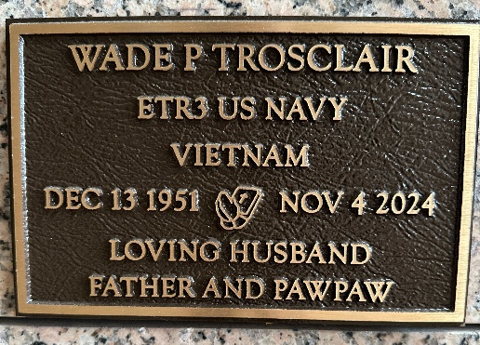
Photo by Team T-Lo

Wade Peter Trosclair passed away on Monday, November 4, 2024, at the age of 72. He was born on December 13, 1951, to the late Paul Edgar Trosclair and Ethel Mae Williams Trosclair. He was a native of Garyville.
He graduated from Leon Godchaux High School in 1969. After high school, he joined the US Navy in 1970. Most of his time in the service was on board the USS Vancouver. While stationed in the navy, he met his loving wife Terri and they have been married for 52 years. After his service in the Navy, Wade worked in the chemical-petroleum industry and retired from Marathon Oil.
Wade was known for his love of baseball and coached little league. He enjoyed taking care of his garden, driving around the community, spending time with his family, and dedicating time to his faith. He never met a stranger and was kind to anyone he met. Wade loved his family, friends, community, and country. He had a huge love of God and showed his faith by serving in various roles at St. Hubert Catholic Church.
He is survived by and was the beloved husband to Teresa "Terri" Stickler Trosclair and loving father of Susan Trosclair Miano (Marc), Rebecca Trosclair Duhon (Damian) and Brian Wade Trosclair (Christina).
He was "Paw Paw" to Anya Trosclair, Alyssa Miano, Jacob Duhon, Megan Miano, Lillian Trosclair, Lauren Duhon, and Alex Duhon. He is also survived by his brothers Darryl Trosclair (Cindy), Paul "T Pop" Trosclair (Judy) and sisters Sherry Welch, and Lisa Lozano (David), many cousins, nieces, and nephews.
Relatives and friends are invited to attend the Funeral Service at St. Hubert Catholic Church, 176 Anthony F. Monica St., Garyville on Friday, November 8, 2024. Visitation will be held in church from 9:00 a.m. until time of Mass at 11:00 a.m. Interment will be in St. Peter Catholic Cemetery.
In lieu of flowers, please consider a donation in his memory to your charity of choice.

Millet-Guidry Funeral Home, LaPlace, Louisiana
November 6, 2024

