Joseph Olide Troxclair
July 29, 1901 – July 16, 1971

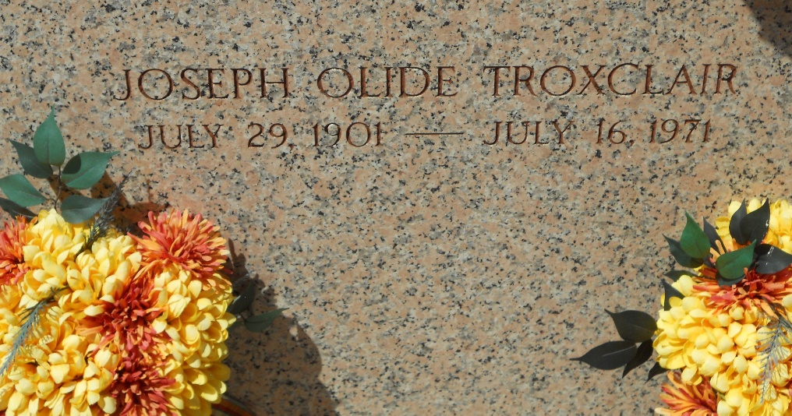
Photo by Team T-Lo

TROXCLAIR

Joseph Olide Troxclair, on Friday, July 16, 1971, at 10:20 o’clock p.m., beloved son of the late Cyr Benoit Troxclair and Marie Arthemise Schexnayder; brother of Miss Melanie Pauline Troxclair and Joseph, George, Hubert Joseph, Josep Benoit, Edward joseph and Claude Calocer Troxclair, all of Mt. Airy, La.; Telesphore Raymond Troxclair of Plaquemine, La., Mrs. L. F. (Stella) Zeringue of New Sarpy, La., and the late Ronald Albert, and Louise Troxclair, age 69 years, a native of Live Oaks, La., and a resident of M. Airy, La., for the past 62 years.
Relatives and friends of the family, also Employees of Kaiser Aluminum & Chemical Corp., Gramercy, La., are invited to attend the funeral. Services from Millet Funeral home, Reserve, La., on Monday, July 19, 1971, at 9:30 o’clock a.m., followed by religious services at St. Hubert’s Catholic Church, Garyville, La., at 10:00 o’clock a.m. Entombment in St. Peter’s cemetery, Reserve, La. Friends may call after 2:30 p.m. Sunday.

Unknown newspaper clipping

