Lillie Marie (Miller) Troxclair
August 5, 1911 – April 16, 1976
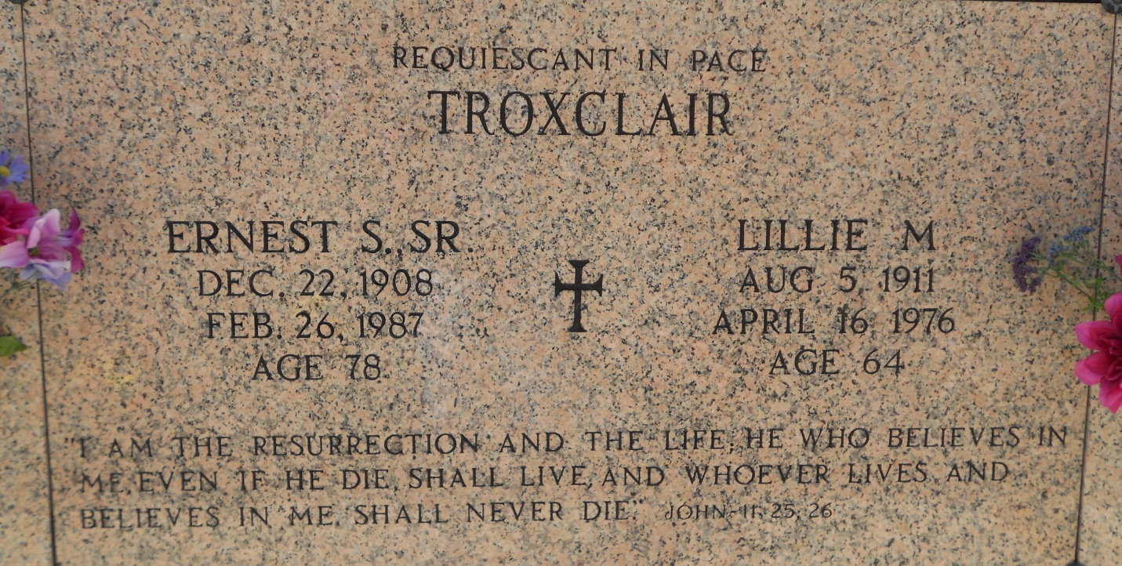
Photo by Team T-Lo

Funeral services for Lillie M. Troxclair of Lutcher were held Monday, April 19, from St. Joseph Catholic Church, Paulina, with interment in the St. Peter Mausoleum, Reserve. Mrs. Troxclair, the former Lillie Miller, died April 16. She was 64 years old, and a native of Belmont.
She is survived by her widower, Ernest S. Troxclair; one son, Ernest S. Troxclair Jr., of Norco; two daughters, Mrs. John (Mary Ann) Daigle of Gramercy and Mrs. Wayne (Lucy) Duhe of Lutcher; three brothers, Willie and Alfred Miller Jr. of Reserve; Clarence Miller of Lutcher; three sisters, Emelie M. Bourgeois, Gramercy; Lelia M. Landry, Norco and Lois Miller, Reserve; nine grandchildren and one great-grandchild.
L'Observateur, LaPlace, Louisiana
Thu, 22 Apr 1976, pg. 4

