Marceline (Schexnayder) Troxclair
1858 – May 18, 1941

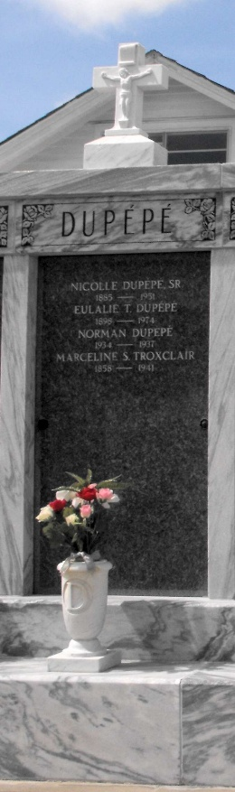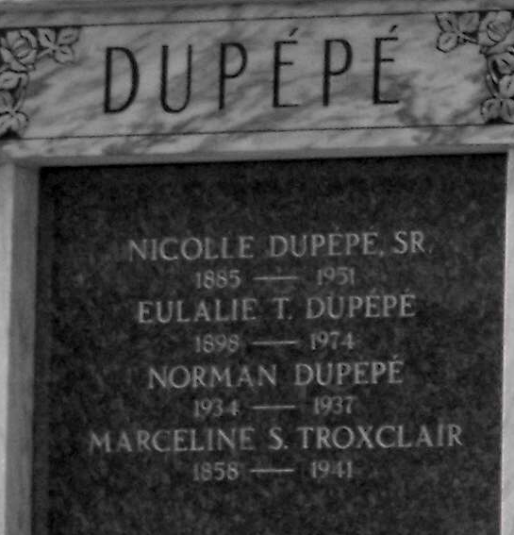
Photos by Mary Agnes Hammett

Died at Reserve, Louisiana, on Sunday, 18 May 1941 at 9:30 pm. Wife of
A. Troxclair and mother of Valeriea, Antoinette, Sabin, Wilfred, Bonaface and Eulale Troxclair. Age 83 years.

Services were Monday, 19 May 1941 at St Peter Church, Reserve, with interment in St Peter Cemetery.
The Times-Picayune, New Orleans, Louisiana
19 May 1941

