Melanie Pauline Troxclair
January 7, 1898 – April 28, 1977

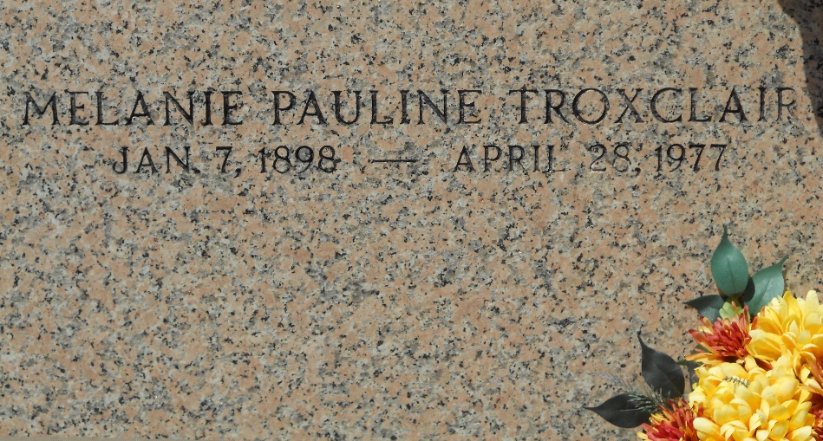
Photo by Team T-Lo

TROXCLAIR

Melanie Pauline Troxclair, on Thursday, April 28, 1977, at 2 a.m., beloved daughter of the late Syr Benoit Troxclair and Marie Arthemise Schexnayder; sister of George, Hubert, Benoit, Edward and Claude Troxclair, all of Mt. Airy, La., Mrs. L. F. (Stella) Zeringue Sr. of New Sarpy, La., T. R. Troxclair of Plaquemine, La., also the late Olide, Albert, and Louise Troxclair, age 79 years, a native and resident of M. Airy, La.
Relatives and friends of the family are invited to attend the funeral services from Millet Funeral Home, Reserve, La., on Friday, April 29, 1977 at St. Hubert’s Catholic Church, Garyville, La., at 10:30 o’clock a.m. Interment in St. Peter’s Cemetery, Reserve, La. Friends may call from 5 p.m. to 11 p.m. on Thursday, April 28, and from 8 a.m. until services on Friday, April 29.

Unknown newspaper clipping

