Harry Anthony Troxclair Sr.
April 15, 1923 – August 1, 1969

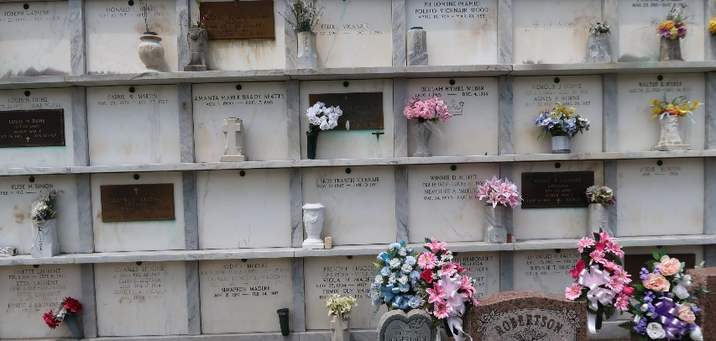

Deputy Harry Troxlair was killed when his patrol car was struck by an Illinois Central Railroad passenger train as he responded to a domestic disturbance at 8:48 am at Frenier Road.

Deputy Troxlair was a United States Navy World War II veteran and had served with the St. John the Baptist Parish Sheriff's Office for 18 years. He was survived by his wife, three children, father, two brothers, two sisters, and three grandchildren.

St. John the Baptist Parish Sheriff's Office, Louisiana
End of Watch: Friday, August 1, 1969
**

Remembering Deputy Harry Troxlair Sr.
Today we remember Deputy Harry Troxlair Sr. who died as a result of a vehicle-train accident on this day in 1969. Deputy Troxlair was killed when his patrol car was struck by an Illinois Central Railroad passenger train as he responded to a domestic disturbance. Deputy Troxlair had served with the agency for 18 years.

St. John the Baptist Parish Sheriff's Office, Louisiana
A͏u͏g͏u͏s͏t͏ ͏1͏,͏ ͏2͏0͏2͏5͏

