Elmore J. Troxler
October 29, 1917 – December 22, 1998

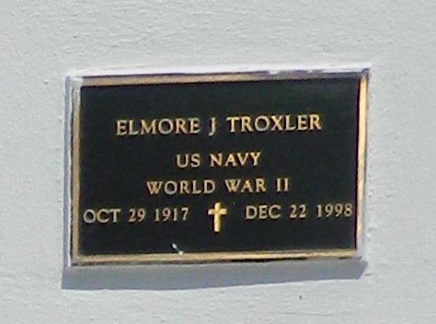

Elmore J. "Sweety" Troxler, 81, a native of Taft and a resident of LaPlace for 50 years, died Dec. 22.
He was the husband of Mary Camallo Troxler and father of Jenny Conrad and Peggy Granier. He was also the son of the late Johnny and Bertha Hymel Troxler and brother of Myrtle Miano, Theresa Blackledge, Roland, Richard and Dr. Ferdinand Troxler. He is also survived by four grandchildren.
Services were held Dec. 24 at St. Joan of Arc Catholic Church, LaPlace, with interment at St. Peter Cemetery, Reserve.
L'Observateur, LaPlace, Louisiana
December 28, 1998

