John Francois “Johnny” Troxler
July 1, 1880 – January 24, 1945

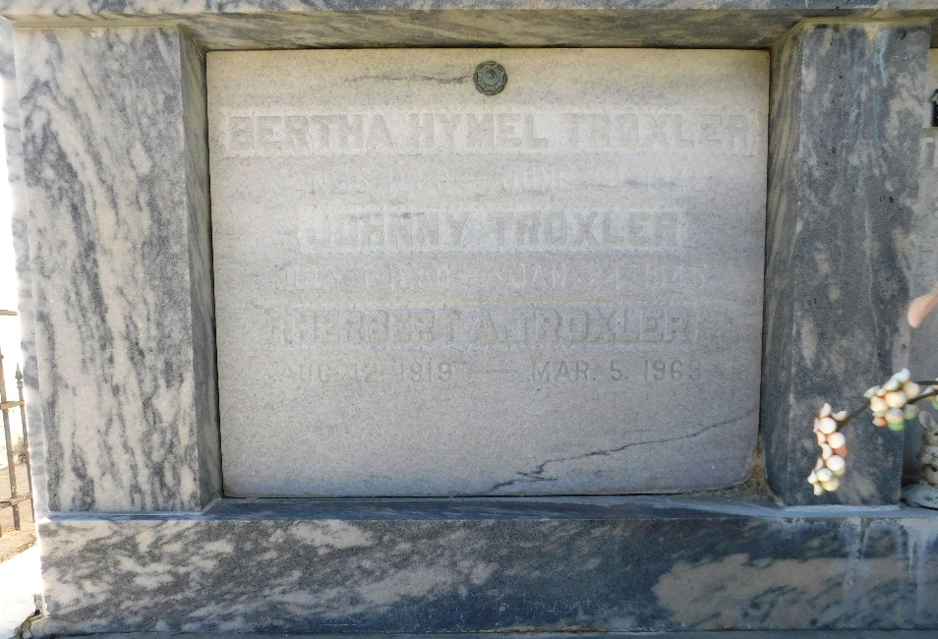
Photo by Mary Agnes Hammett

TROXLER - At his residence on Wednesday, January 24, 1945, at 4:40 o'clock a.m., JOHNNY TROXLER, husband of the late Bertha Hymel, father of Kittredge and Myrthe Troxler and Mrs. L. G. Montz of Reserve, La, Mrs. A. A. Macaluso, Lucien, Dr. Joachim, Clifford and Theresa Troxler of New Orleans, La, Roland Troxler of Knoxville, Tenn, Major F. A. Troxler and Technical Sergeant H. A. Troxler U.S. Army, Elmore J. Troxler, Yeoman 1/c U.S. Navy, and Richard J. Troxler, Merchant Marine, brother of Mrs. George Becnel, Mrs. Eva Brown, James and John Troxler, age 65 years.

Relatives and friends of the family are invited to attend the funeral which will take place from the Jules Millet Funeral Home, Reserve, La, on Thursday morning, January 25, 1945, at 9:30 o'clock, followed by religious services at St Peter's church, Reserve, La. Interment in St Peter Cemetery.

The Times-Picayune, New Orleans, Louisiana
25 Jan 1945, p. 2

