Guy George Trudeau
July 20, 1897 – October 3, 1987

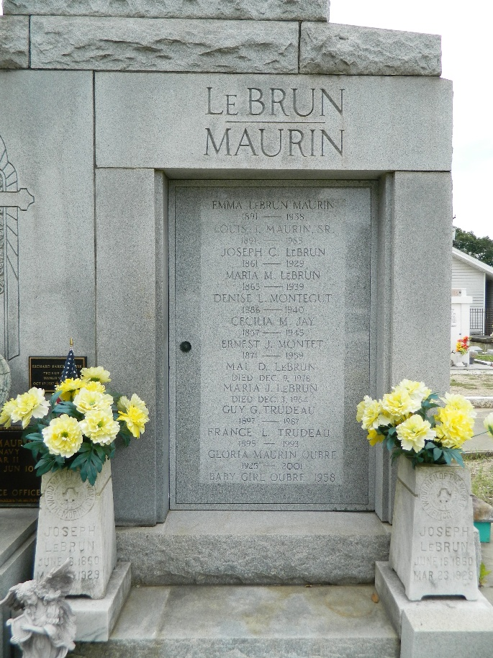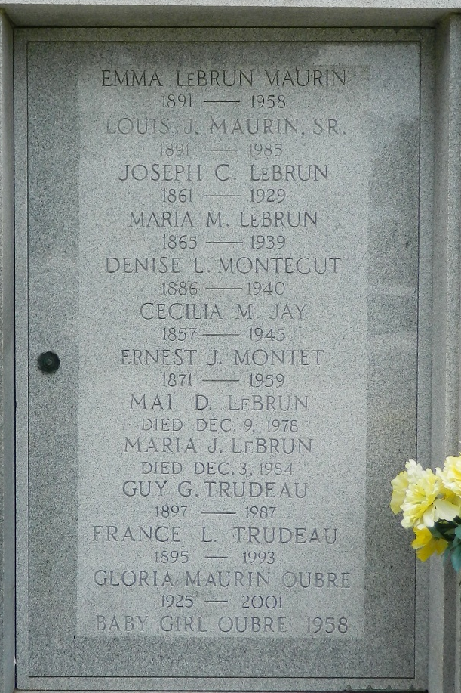

Guy George Trudeau died on Saturday 3 Oct 1987 at 11:33 o'clock p.m. He was the husband of France LeBrun Trudeau and the brother of Mrs. Ethel T. White and the late Malcolm Trudeau, Lucille T. Guglielmo, Lola T. Blanchard, Claire, Zima and Renee Trudeau. He was age 90 years, a native of Convent, Louisiana, and a resident of Reserve, Louisiana, for the past 62 years.

Relatives and friends of the family, also employees of Bank of St John, are invited to attend the funeral services from Millet Funeral Home, Reserve, on Monday 5 Oct 1987 followed by Mass of Christian Burial at St Peter Catholic Church, Reserve. Interment in St Peter Cemetery, Reserve.

The Times-Picayune, New Orleans, Louisiana
October 5, 1987

