Byron Joseph Tuircuit
December 15, 1966 – June 20, 2023

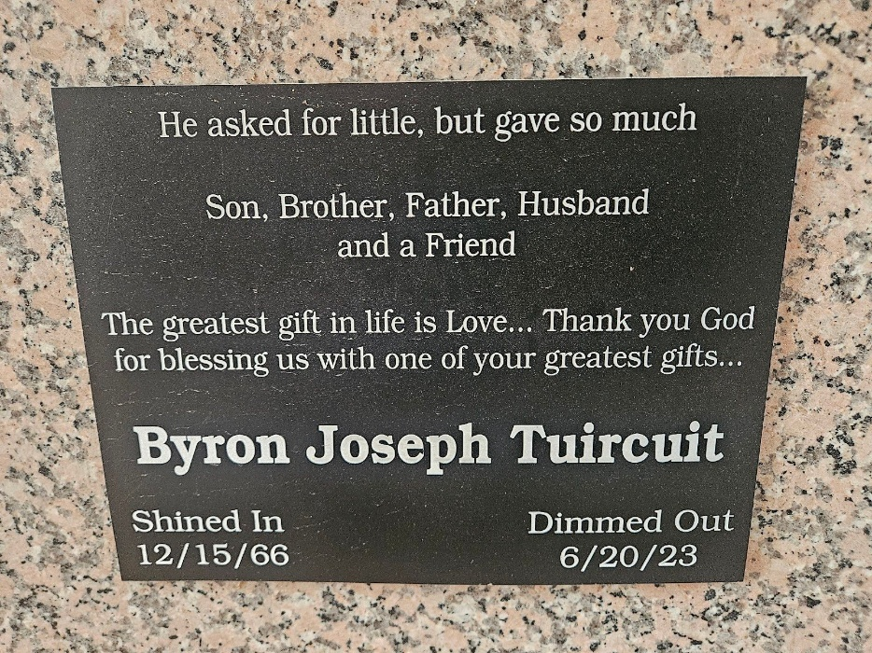
Photo by Team T-Lo

Byron Joseph Tuircuit, age 57 departed this life on Tuesday, June 20, 2023. Son of the late Diane Burl Tuircuit and Everage J. Tuircuit Jr. Husband of Tonia King Tuircuit.
Father of Auntranica, Byron "BJ", Brittney, Brianna and Thiery Tuircuit, step-father to Paige King and Paiton Anderson. Brother of Laurie T. Warren, Everage Jr, Tyrone and Jermaine Tuircuit and Grandson of Herbert Burl Jr. He is also survived by a host of other relatives and friends.
Celebration of Life will be held on Saturday, July 1, 2023, at Bethlehem Baptist Church, 146 E.20th St., Reserve, LA 70084, Rev. Forell Bering, Sr., Pastor. Pastor Bryant K. Warren, Sr., Officiating. Interment in St. Peter Catholic Cemetery.

The Times-Picayune, New Orleans, Louisiana
June 29-30, 2023

