Diane (Burl) Tuircuit
March 16, 1948 – April 22, 2009

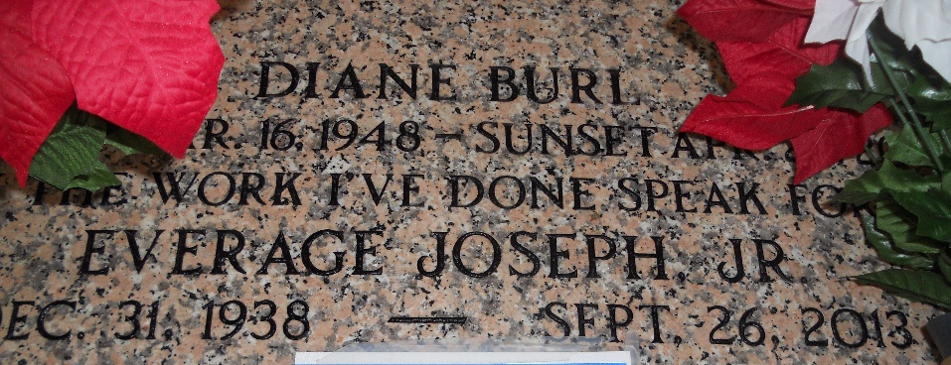
Photo by Team T-Lo

Diane Burl Tuircuit, A Homemaker, Age 61, Received Her Passport To Bright Glory On Wednesday, April 22, 2009 At Her Residence In Reserve LA.
Daughter Of Herbert Jr. And Helen Burl. Proud Wife Of Everage Tuircuit, Jr. Devoted Mother And Mother-In-Law Of Everage III (Rolanda), Tyrone (Amanda), Jermaine (Lequisha), Byron (Kim) Tuircuit, Lauri T. Boyd And The Late Darold Boyd, Sr. And Her Little Angel Darryl Tuircuit. Sister Of David And Darrin Burl, Barbara Foster, Pollet Frazier And The Late Chuckie Bruce Burl, Sr. Niece Of Morgan Burl Sr., Cornelius Rixner And Fabiola Burl Mills. Also survived by 15 grandchildren, 3 great-grandchildren, brothers- and sisters-in-law and a host of nieces, nephews, other relatives and friends.
A Native Of Mt. Airy, LA And Resident Of Reserve, LA.
Funeral Service will be held on Monday, April 27, 2009 at 11:00a.m. at St. Mark Baptist Church, 132 Marquez St., Mt. Airy, LA. Elder Oscar Nelson, Sr., Pastor - officiating. All neighboring churches are invited to attend, Interment in St. Peter Cemetery in Reserve, La. Visitation will be held at Hobson Brown Funeral Home on Sunday, April 26, 2009 from 5:00-7:00 p.m. and at the above named church from 9:00 a.m until service time on Monday. Service entrusted to Hobson Brown Funeral Home Garyville, La. (985) 535-2516.

The Times-Picayune, New Orleans, Louisiana
April 26, 2009

