Everage Joseph Tuircuit, Jr.
December 31, 1938 – September 26, 2013

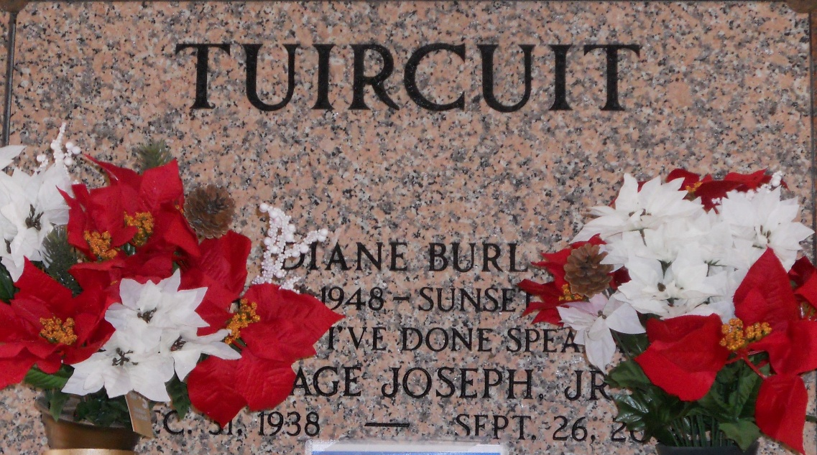
Photo by Team T-Lo

Everage Tuircuit, Jr., passed away Thursday, September 26, 2013, at the age of 75 years old. Son of the late Magary and Everage Tuircuit, Sr. Husband of the late Diane Burl Tuircuit. Father of Laurie (Rev. Bryant) Warren, Everage, III (Rolanda), Tyrone (Amanda), Byron, Jermaine (Claudine), and the late Darryl Tuircuit. Also survived by a host of brother, sisters, nieces, nephews, grandchildren, other relatives and friends.

Funeral services will be held at Our Lady of Grace Catholic Church, 772 Highway 44, Reserve, La. on Friday, October 4, 2013 for 10:00 a.m. Visitation will be from 8:15 a.m. until time of service. Father Christopher Amadi will be officiating. Interment will be at St. Peter Cemetery, Reserve, La. Funeral entrusted to The Baloney Funeral Home, LLC., 1905 W. Airline Highway, Laplace, La., 985-224-8460.

The Times-Picayune, New Orleans, Louisiana
September 30 – October 2, 2013

