Michael Joseph Tuircuit Sr.
January 10, 1942 – August 1, 2012

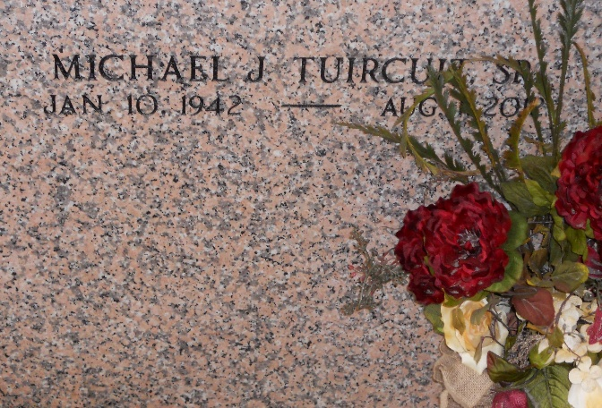
Photo by Team T-Lo

Michael Joseph Tuircuit, Sr. on Wednesday, August 1, 2012 at Ochsner Medical Center, Jefferson, LA.
Son of the late Magary Thompson and Everage J. Tuircuit, Sr. Beloved husband of Louise Batiste Tuircuit. Father of Michael Joseph Tuircuit, Jr. (Deidra), Myra J. Tuircuit Brown (Michael), Roxann Laverne Tuircuit, and Lisa Juanette Tuircuit. Brother of Everage J. Tuircuit, Jr., Sophie B. Tuircuit, Margie T. Wilkins, Andrew J. Tuircuit, Sr., the late Catherine T. Cook, Shirleen T. Tassin and Sylvia Tuircuit. Also survived by 6 grandchildren, 5 great-grandchildren and a host of nieces, nephews, cousins, other relatives and friends. Age 70 years. A native and resident of Reserve, LA.
Relatives and friends of the family, also priest and parishioners of Our Lady of Grace Catholic Church and all neighboring churches are invited to attend the Funeral Mass at Our Lady of Grace Catholic Church, 772 Highway 44, Reserve, LA on Thursday, August 9, 2012 at 10:00 AM. Father Christopher Amadi, Celebrant. Interment St. Peter Cemetery, Reserve, LA. Visitation at the above named church from 8:30 AM until Mass time. SERVICED BY ROBOTTOM.

The Times-Picayune, New Orleans, Louisiana
August 4-8, 2012

