Vallery (Toney) Tuircuit
February 14, 1955 – June 5, 2004

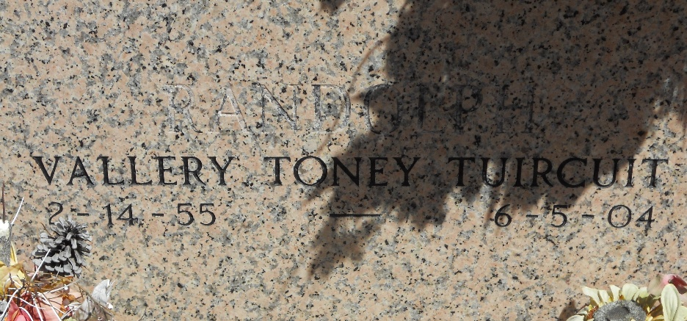
Photo by Team T-Lo

Vallery Toney Tuircuit On Saturday, June 5, 2004 At Canon Hospice, Jefferson, La. Daughter Of Rosemary 'Ruby' Toney And The Late Pershing 'Bunny' Toney, Sr.
Mother Of Andrew Tuircuit, Jr., Andrea, Andrietta And Angelle Toney. Sister Of Mala Taylor, Terry Jones, Alana Griggs And Pershing (Petey) Toney, Jr. Niece Of Ethel Toney Of New Orleans, La, Rita Cadell Of Compton, Ca, And Ida 'Angel' Duval Of Austin, Tx. Grandmother Of Tre'shayne, Tyree And Ty'jna Tuircuit. Mother-In-Law Of Shareen Tuircuit. God Daughter Of Joseph Valentine. Also Survived By A Host Of Nieces, Nephews, Other Relatives And Friends. Age 49 Years. A Native And Resident Of Reserve, La.
Relatives And Friends Of The Family, Also Pastors, Officers And Members Of New Wine Christian Fellowship, Priest And Parishioners Of Our Lady Of Grace Catholic Church And All Neighboring Churches Are Invited To Attend The Funeral Service From New Wine Christian Fellowship Church, 1929 Airline Highway, Laplace, La. On Friday, June 11, 2004 At 11:00 Am. Pastor Neil Bernard, Officiating. Interment St. Peter Cemetery, Reserve, La. Visitation At The Above Named Church From 10:00 Am Until Service Time. Serviced By Robottom.

The Times-Picayune, New Orleans, Louisiana
June 10, 2004

