Nathan Thomas Vatter
October 15, 2003 – May 28, 2006

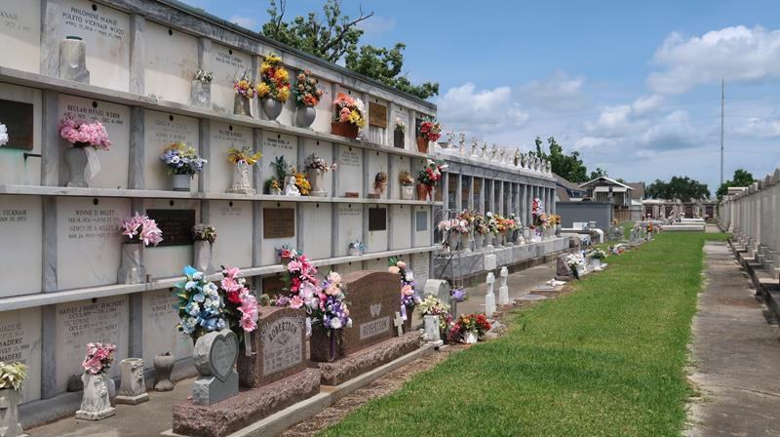

Nathan Thomas Vatter, a resident of Laplace, Louisiana, entered into eternal rest on May 28, 2026, at the age of 22.
Nathan was a kind soul and was loved by all who knew him. He was a well decorated young man who had many accomplishments. Nathan attended Jesuit High School in New Orleans, where he was a Captain in the MCJROTC and graduated Summa cum laude in 2022. He was also involved in the Right to Life Organization, working towards making a difference in people's lives in every way that he could. Nathan was also named Altar Server of the Year, where he represented St. Joan of Arc Catholic Church for the Archdiocese of New Orleans.
He continued his education at Southeastern and where he recently earned the Honors distinction as an Honors graduate anticipated graduation in Summer of 2026 from Southeastern University. He was also a member of the Student Government Association and was even nominated Senator of the Year. He was an avid reader and enjoyed listening to various podcasts in his free time. He loved history, and was passionate about all things related to politics, government, and the constitution.
His best times were when he was with his family and watching movies with them. Nathan loved going on family vacations to the beach and Disney World. He adored his sister Kate dearly and often reminded her of how proud he was of her.
Nathan is survived by his parents, George and Allison Vatter; his sister, Kate Vatter; his maternal grandparents, Thomas and Janice Stayton; his uncle, Noah Stayton (Andrea); his aunt, Pam Riley (Duane); and his cousins, Candice Galliano, Thomas Hathcock, and Layla Stayton. He is preceded in death by his paternal grandparents George and Charlotte Vatter.
Relatives and Friends are invited to attend the Visitation and Funeral Mass for Nathan on Tuesday, June 2, 2026, at St. Joan of Arc Catholic Church, located at W. 5" St., Laplace, Louisiana 70068. The Visitation will be held from 12:00 p.m. until 2:00 p.m. The Funeral Mass will begin at 2:00 p.m., and interment will follow immediately after at St. Peter Catholic Cemetery in Reserve, LA.

Millet-Guidry Funeral Home, LaPlace, Louisiana
May 31, 2026

