Blanchard Fabian Verzwyvelt
January 24, 1939 – May 5, 2012

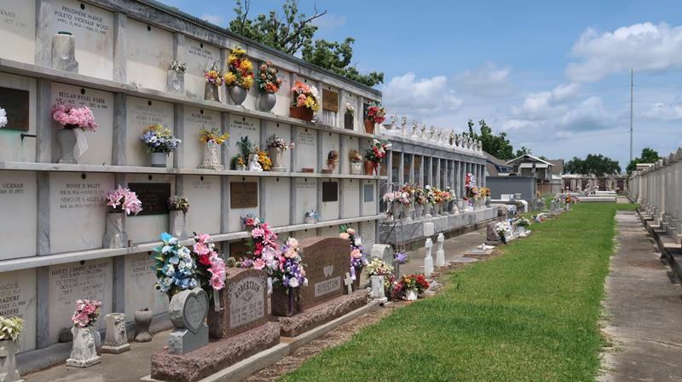

Fabian Blanchard Verzwyvelt, a resident of LaPlace, La., entered eternal life on May 5, 2012 at the age of 73 years.
He is preceded in death by his wife, Delores, his parents, Fabian and Eva Verzwyvelt, and one brother, Richard Verzwyvelt. He is survived by two sisters, Sister Margaret Ann Verzwyvelt and Joyce Verzwyvelt Dekeyzer, and two brothers, George Verzwyvelt and Carl Verzwyvelt.
Blanchard graduated from Menard High School in Alexandria and then joined the Marine Service in the Military. Upon returning to civilian life he was employed by Boyce Machinery Co. where he worked until his retirement after 42 years.
As a teen, he was very active in the 4-H Club and helped his Dad on the farm. Blanchard loved to garden and even though his garden was very small, he loved sharing the vegetables with friends and neighbors. He was a member of and an usher at St. Joan of Arc Catholic Church in LaPlace. Blanchard willed his body to Science Medical Research.
Now God has a new resident in Heaven enjoying eternal peace and happiness. We miss him, but we know his spirit is with us and will continue to be with us.
There are two Memorial masses scheduled:
St. Joan of Arc Catholic Church, LaPlace, La. May 19th, 11:00 a.m.
St. Rita Catholic Church, Alexandria, La. June 9th, 10:00 a.m.
The Town Talk, Rapides Parish, Louisiana on May 13, 2012

Note: Ashes were returned and buried in St. Peter Cemetery on June 22, 2019

