Cecile (Triche) Vice
October 14, 1903 – February 22, 2000

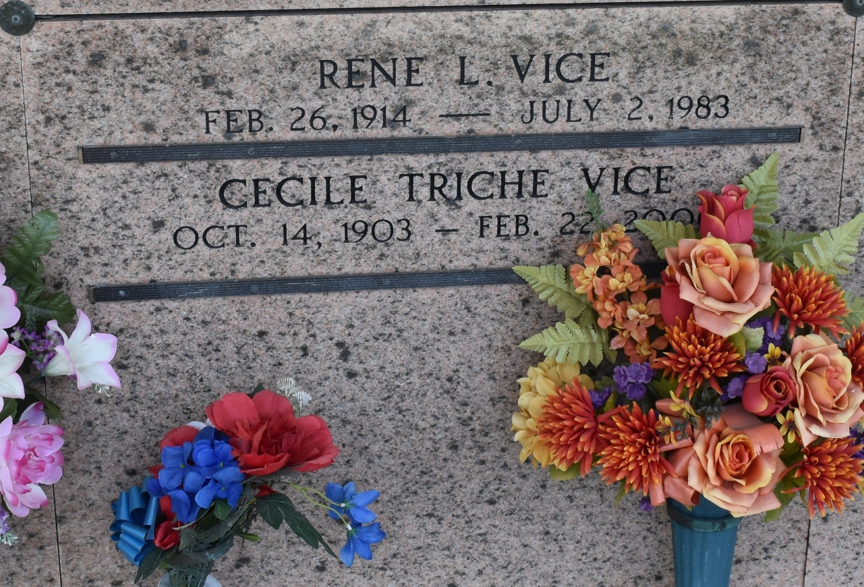

Cecilia Triche Vice, On Tuesday, February 22, 2000 At 10 A.M.
Beloved Wife Of The Late Rene L. Vice. Mother Of Sheldon Vice. Mother-In-Law Of Sherry B. Vice. Grandmother Of Rick And Sheldon Vice, Jr., Wanda V. Loupe And Nicole Vice.
Daughter Of The Late Andrien And Amelia Triche. Sister Of The Late Arthur, Maurice, Charles And Alcee Triche, Herminie Duhe, Leoncia Klibert And Aileen Leger. Also Survived By 4 Great-Grandchildren.
[Note: married Leo Rene Vice; Bobby Migues]
Unknown source

