Abraham Vicknair
March 26, 1894 – August 8, 1950

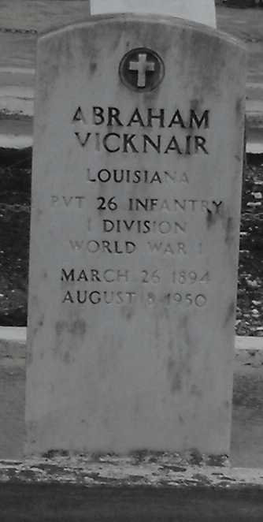
Photo by Mary Agnes Hammett

VICKNAIR - In Montz, La, on Tuesday, August 8, 1950, at 5:45 o'clock p.m., ABRAHAM VICKNAIR, beloved husband of Christiana Tassin; father of Mrs. Joseph Sparisiana(?) and Ernest and Anna Mae Vicknair; aged 56 years.

Relatives and friends of the family are invited to attend the funeral which will take place from Millet's Funeral Home, Reserve, La., on Thursday, August 10, 1950, at 8:30 o'clock a.m., followed by religious services at St Joan of Arc church, Laplace, La, at 9 o'clock. Interment in St Peter's Cemetery, Reserve, La.
The Times-Picayune, New Orleans, Louisiana
10 Aug 1950, p. 2

