Achille Vicknair
October 1887 – March 10, 1924

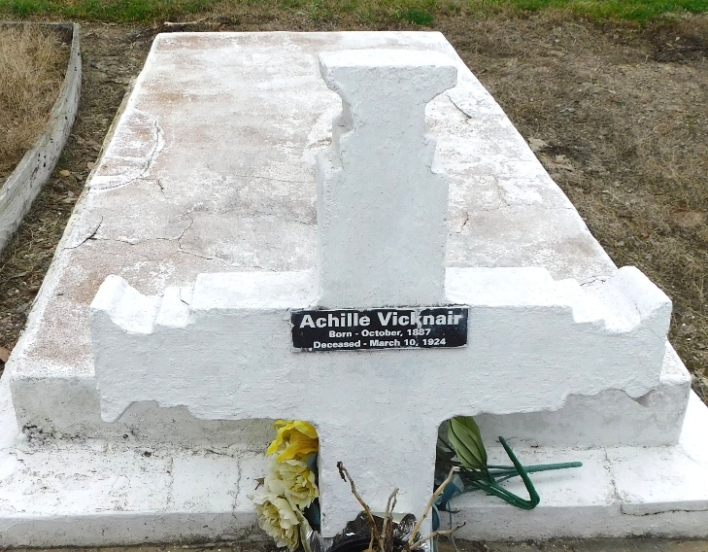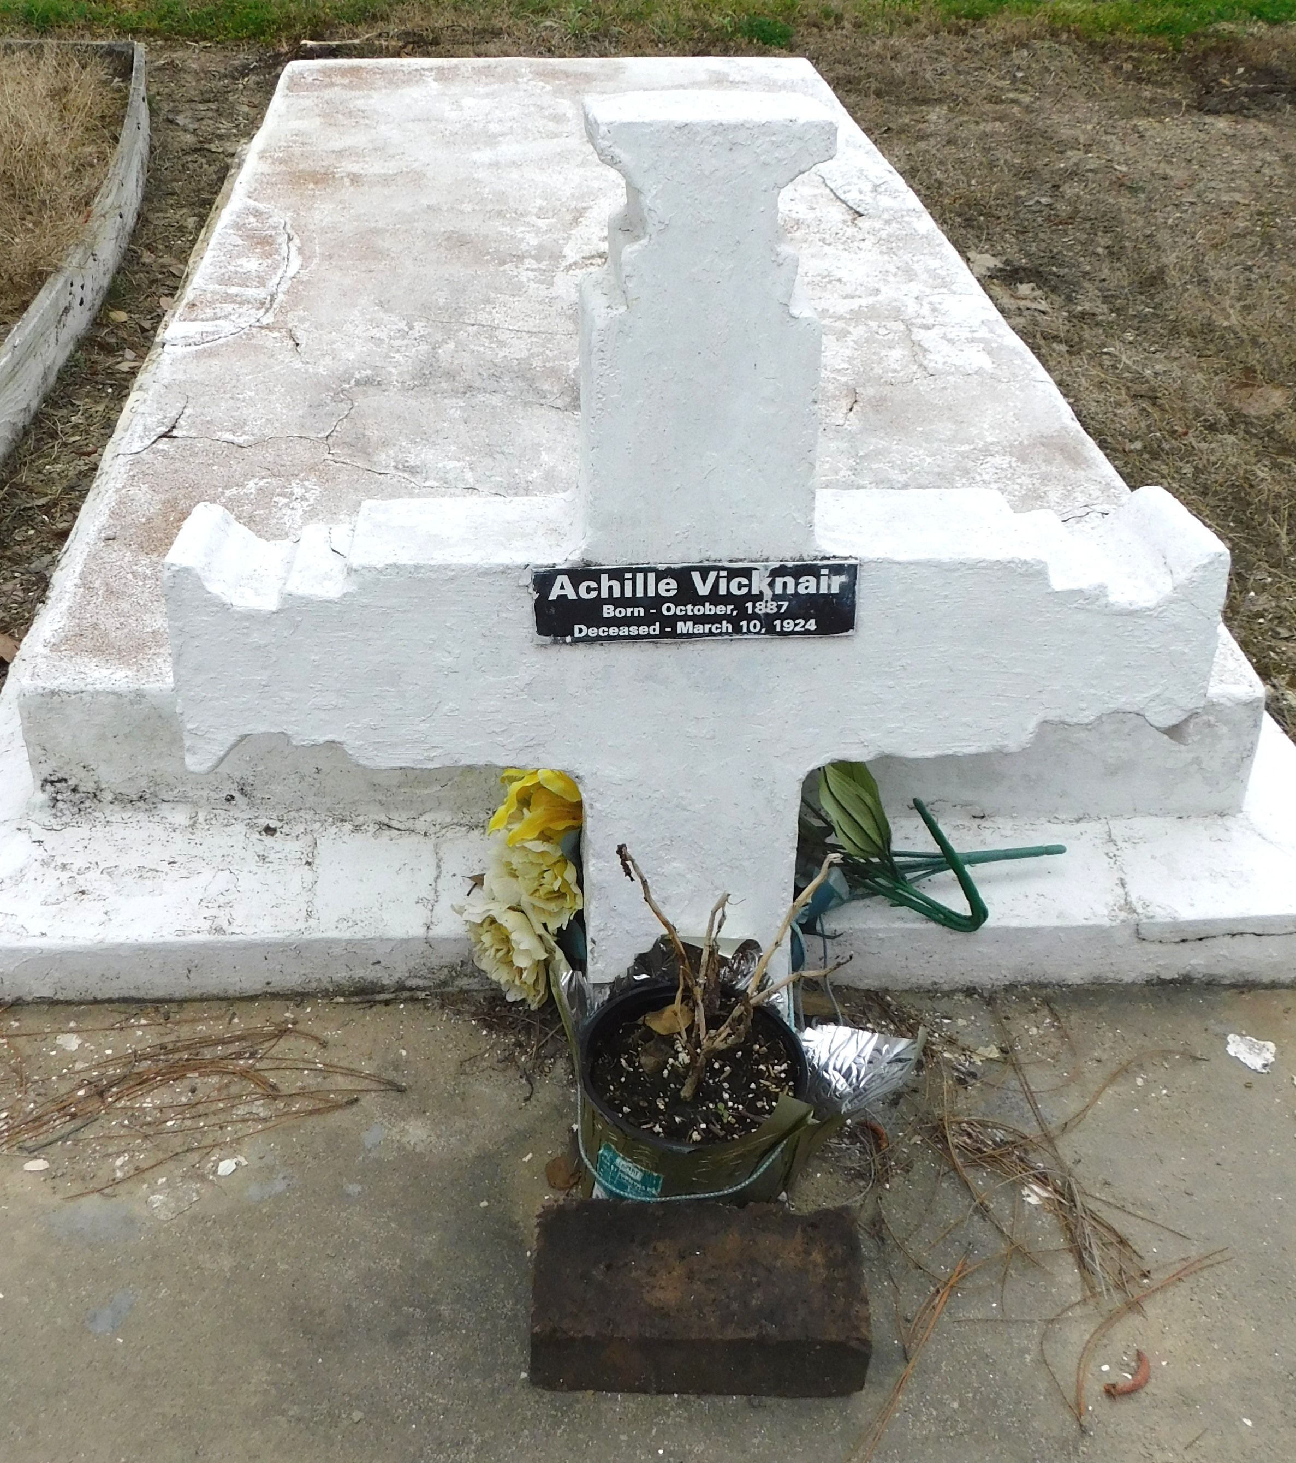
Photo by Mary Agnes Hammett

Mr. Achille Vicknair, an employee of the Godchaux Sugars, Inc., oof Reserve, left his home about a month ago for the Charity Hospital to be operated on for appendicitis. The operation was performed and proved a success, for he was well and ready to come back home, when, last Friday, friends went down to get him, arriving at the Hospital they learned that Mr. Vicknair had a high fever and that his condition was growing worse and worse when, Tuesday night, at 7:00 o’clock, He died. His body was brought here Wednesday and Thursday afternoon he was buried in the local cemetery following services at St. Peter’s Church.
Mr. Vicknair was 37 years old and leaves a heart-broken widow and five your children to mourn his sad and untimely demise. The Reserve Lodge No. 15, Benevolent Knights of America of Louisiana, of which he was a member, had charge of the funeral.

L’Oservateur, LaPlace, Louisiana
March 15, 1924
**

Dwayne Montz research note

Believed to be the son of Pierre Ursin Vicknair and Felicite Honorine Perilloux. He married in 1909 to Marie Phillipe. I located the family in the 1910, 1920 and 1930 St John the Baptist Parish census listings. Marie is a widow in the 1930 listing with 5 children.

