Adolphine Vicknair
February 17, 1883 – July 18, 1930

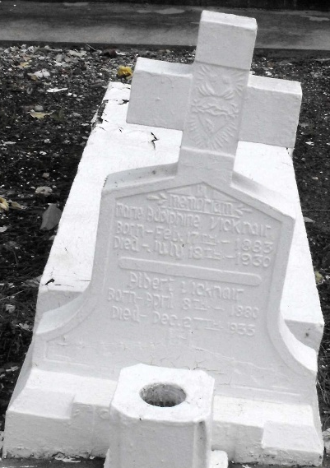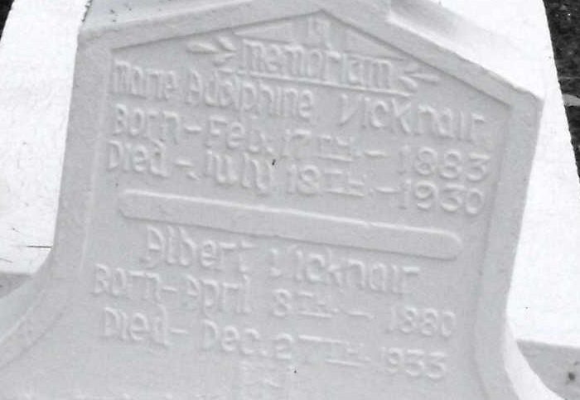
Photos by Mary Agnes Hammett

Miss Adolphine Vicknair

After a long and lingering illness Miss Adolphine Vicknair, a native and life-long resident of this parish, died at her home at Reserve last Friday after-noon at 5:55 o’clock. Her funeral took place the following day at Saint Peter’s Catholic Church in the presence of a large concourse of relatives and friends after which her remains were laid to rest in the local cemetery.

Deceased, who was about 45 years old, is survived by five brothers, Aristide, Ozemee, Albert, Felicien and William Vicknair, all of Reserve.

L’Obervateur, LaPlace, Louisiana
Saturday, July 26, 1930, p. 1

