Adolphine (Brignac) Vicknair
July 2, 1906 – December 31, 1971

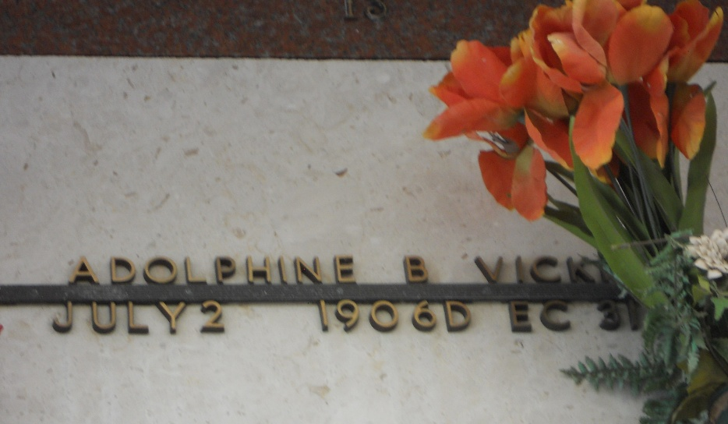
Photo by Team T-Lo

VICKNAIR
Adolphine Brignac Vicknair on Friday, December 31, 1971, at 1:30 o'clock p.m., beloved wife of Benoit Vicknair of Reserve, La; mother of Norris P and Everett F Vicknair of Reserve, La; sister of Mrs. Andrew (Rene) Klibert, Mrs. Leah Gaudin, Mrs. Faustine Watz of Houston, Texas, Mrs. Inez Chauvin of Port Allen, La, Mrs. Elvina Amedee, Mrs. Althea Oden and Andrew Brignac of Baton Rouge, La, Adolph Brignac of Garyville, La, and McAllen Brignac of Reserve, La; also survived by three grandchildren, age 65 years; a native of Paulina, La, and a resident of Reserve for the past 45 years.

Relatives and friends of the family are invited to attend the funeral. Services from Millet Funeral Home, Reserve, La, on Monday, January 3, 1972 at 10 o'clock a.m. Religious services at St Peter Church, Reserve, La. Interment in St Peter Mausoleum, Reserve, La.

The Times-Picayune, New Orleans, Louisiana
2 Jan 1972, p. 14

