Albert Vicknair
December 13, 1892 – June 17, 1968

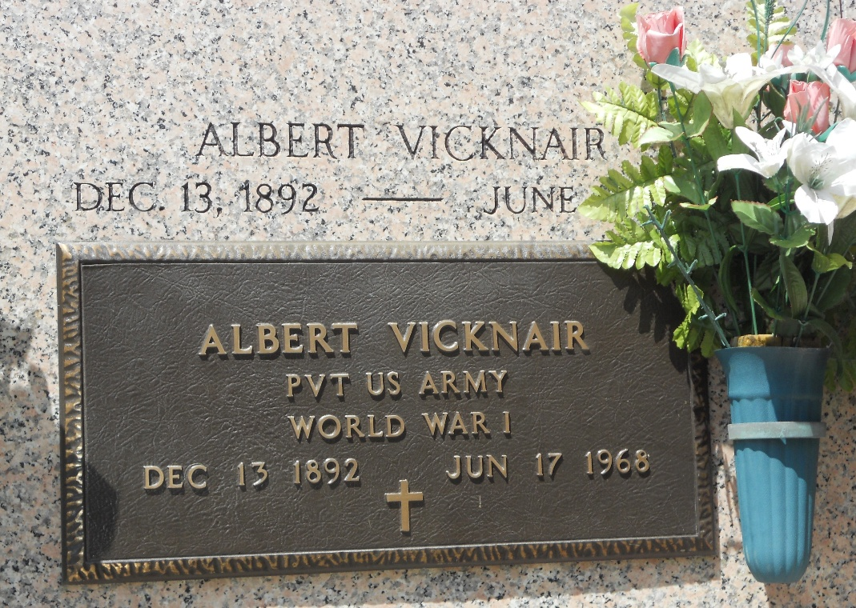
Photo by Team T-Lo

Albert Vicknair, Age 75 years, a native and resident of Reserve, Louisiana.

Husband by first marriage of the late Olga Ory and now the husband of Martha Cox. Father of Mrs. Marjory Williams and brother of Mrs. Ida Giroir and Edwin Vicknair of Reserve, Mrs. Eunice Wagner and Mrs. Agnes Schmidt of New Orleans.

Services were Wednesday 19 Jun 1968 at St Peter Church in Reserve with interment in St Peter Cemetery.

The Times-Picayune, New Orleans, Louisiana
19 Jun 1968

