Alva Mae (Lassere) Vicknair
January 19, 1924 – September 18, 2006

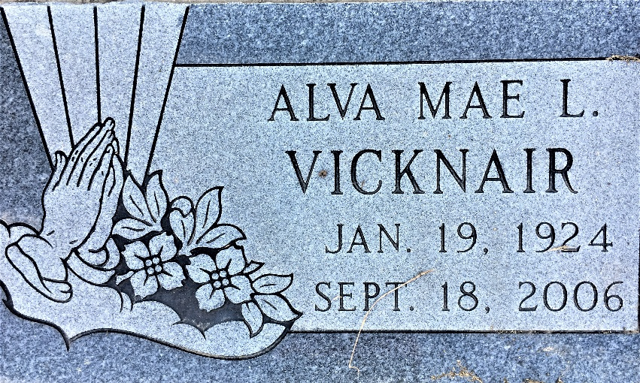
Photo by Team T-Lo

Alva Mae Lassere Vicknair passed away on Monday, September 18, 2006, at 6:28 a.m.
Beloved wife of the late Percy Vicknair, Sr. Mother of Percy Vicknair, Jr., Patricia Scholl, Paul and Phil Vicknair and Penny LaBranche. Daughter of the late Joseph and Aureline Lassere. Sister of the late J.D. and Lionel Lassere.
Also survived by 9 grandchildren and 11 great-grandchildren. Age 82. A native and resident of Garyville.
Relatives and friends of the family are invited to attend services. Visitation at Millet-Guidry Funeral Home, 2806 West Airline Highway, Laplace, LA on Wednesday, September 20, from 5 to 9pm, and on Thursday from 8am to 9:30 am, followed by religious services at St. Hubert Catholic Church, Garyville at 10 am. Burial in St. Peter Cemetery, Reserve, LA.

The Times-Picayune, New Orleans, Louisiana
September 19, 2006

