Amanda (Jacob) Vicknair
May 5, 1878 – September 22, 1949

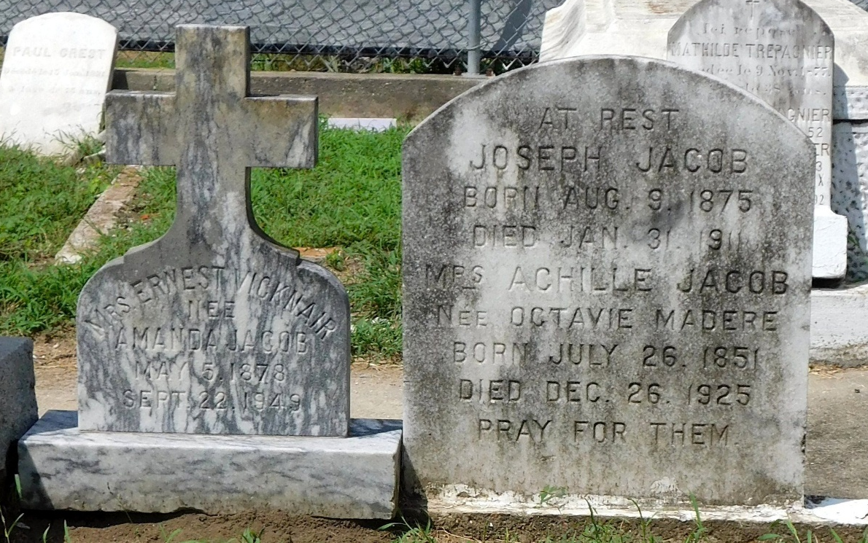
Photo by Mary Agnes Hammett

VICKNAIR - At Laplace, La, on Thursday, September 22, 1949, at 5 o'clock p.m., AMANDA JACOB, wife of the late Ernest Vicknair; mother of Mrs. Ludger Jacob, Mrs. Paul Clement, Mrs. Robert Madere, Mrs. Harry Badeaux, and Lolist Vicknair. Aged 71 years.

Relatives and friends of the family, also employees of Club Forest, are invited to attend the funeral which will take place from Millet funeral home, Reserve, La, on Friday, September 23, 1949, at 4:30 o'clock p.m. Interment in St Peter cemetery, Reserve, La.

The Times-Picayune, New Orleans, Louisiana
September 23, 1949, p. 2

