Amelues Vicknair
December 4, 1880 – May 26, 1949

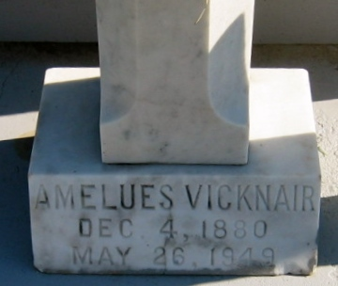
Photo by Bobby

VICKNAIR - At his residence, in Reserve, La, on Thursday, May 26, 1949, at 10 o'clock a.m., AMELUS (JERRY) VICKNAIR, beloved husband of Enzela Boudousquire; brother of Gustave Vicknair; father of Mrs. Paul E. Bourg of Port Arthur, Tex, Mrs. Leo Lasseigne, Mrs. D. J. Labat Jr, Mrs. Eddie Montz, and Francis J. Vicknair, all of Reserve, La; also survived by eight grandchildren. Aged 68 years, 5 months and 22 days.

Relatives and friends of the family are invited to attend the funeral, which will take place from Millet Funeral Home, Reserve, La, on Friday, May 27, 1949, at 4 o'clock p.m., followed by religious services at St Peter's church, Reserve, La. Interment in St Peter's cemetery, Reserve, La.
The Times-Picayune, New Orleans, Louisiana
27 May 1949, p. 2

