Betty (Brown) Vicknair
January 25, 1932 – January 5, 2025

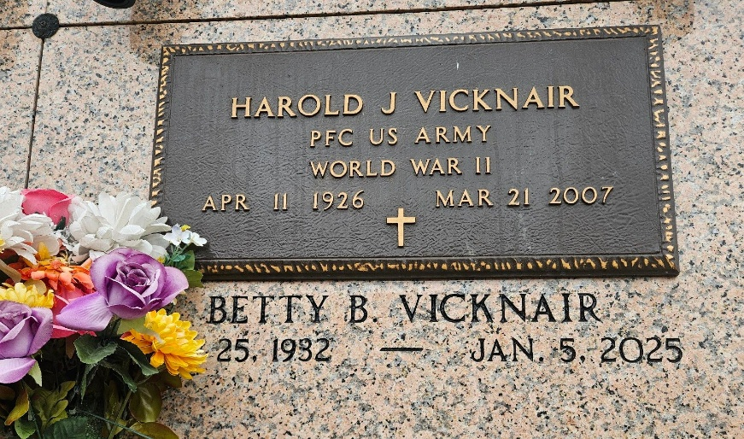
Photo by Team T-Lo

Betty Brown Vicknair passed away on Sunday, January 5, 2025 at the age of 92. Betty was born in Reserve, LA and was a longtime resident of Garyville, LA.
Beloved wife of the late Harold J. “ P-nut” Vicknair for 59 years. Mother of Bryan Vicknair (the late, Phoebe), Randy Vicknair (Debbie), Karla V. Dencausse (Rickey) and the late Dina V. Gremillion. Grandmother of Michael Gremillion, Theresa V. Hayes, Dawn Vicknair, Jennifer V. Catoire, Randi Lyn V. Behrens, Kourtney D. Smith, Kaleb Dencausse and the late Rick Dencausse. Great Grandmother of 11 great grandchildren and 2 great great grandchild-ren.
Daughter of the late Alfred and Bernadette Jacob Brown. Sister of Buster Brown (Linda), Elsie Kereki (John), and the late Myrtle Berteau (Lonnie), Shirley Tamplain, Carole Bordelon, Floyd Brown (Dianna) and Beverly Brown. Also survived by many cousins, nieces, nephews and friends.
Betty was a very active volunteer in Garyville and other areas of St. John the Baptist Parish. She was a parishioner and volunteer at St. Hubert Catholic Church. She received the Order of the St. Louis Medallion in 2009 for all the work she did for the Church. Betty was also very active in the R.S.V.P., A.A.R.P, and was a former Board Member and Officer for the Council of Aging and an Officer and Member of the VFW Ladies Auxiliary 8167 for 60 years.
Relatives and friends are invited to attend the Funeral at St. Hubert Catholic Church, 176 Anthony F. Monica St., Garyville on Friday, January 10, 2025. Visitation will be held in Church from 10:30 a.m. until time of Funeral Mass at 11:00 a.m. Interment in St. Peter Cemetery, Reserve.
Millet-Guidry Funeral Home, LaPlace, Louisiana

