Bruno Vicknair
December 22, 1890 – November 13, 1962

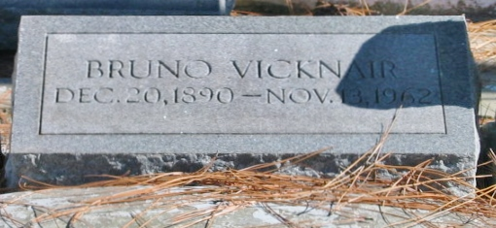
Photo by Bobby

Bruno Vicknair died Tuesday, 13 Nov 1962, at age 74 years.

Husband of Marcelle Bossier and father of Mrs. Jourdan Vicknair, and Donald J, and Alvin J, Vicknair. Brother of Eddie Vicknair.

He was a native and resident of Reserve, LA.

Services were 14 Nov 1962 with interment in St Peter Cemetery.
The Times-Picayune, New Orleans, Louisiana
14 Nov 1962, p. 3

