Caffery Vicknair
March 10, 1898 – June 11, 1968

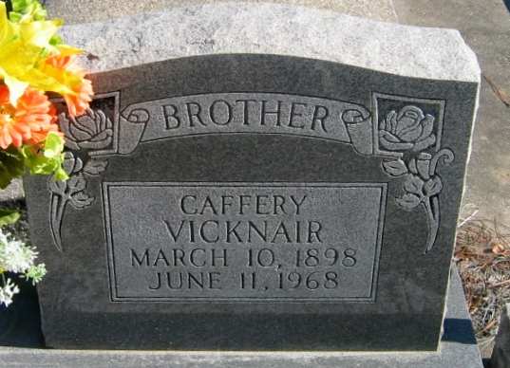
Photo by Bobby

VICKNAIR-On Tuesday, June 11, 1968, at 7:00 o'clock p.m., CAFFERY VICKNAIR, son of the late Frank Vicknair and Molly Bossier, brother of Mrs. Lester Lacour, Mrs. Sidney Luminais, Trezme, Michel, and Fortune Vicknair, all of Reserve, LA, Mrs. Dennis Millet and Mrs. Herbert St Martin of Laplace, LA, and the late Adele Cambre of Reserve, LA; age 70 years; a native and a resident of Reserve, LA.

Relatives and friends of the family, also employees of Godchaux's-Anderson Sugar Refinery, Reserve, LA, are invited to attend the funeral. Services from Millet Funeral Home, Reserve, LA, on Friday, June 14, 1968 at 10:00 o'clock a.m. Religious services at St Peter Church, Reserve, LA. Interment in church cemetery.
The Times-Picayune, New Orleans, Louisiana
13 Jun 1968, p. 20

