Carol (Mehrtens) Vicknair
February 25, 1940 – September 7, 2018

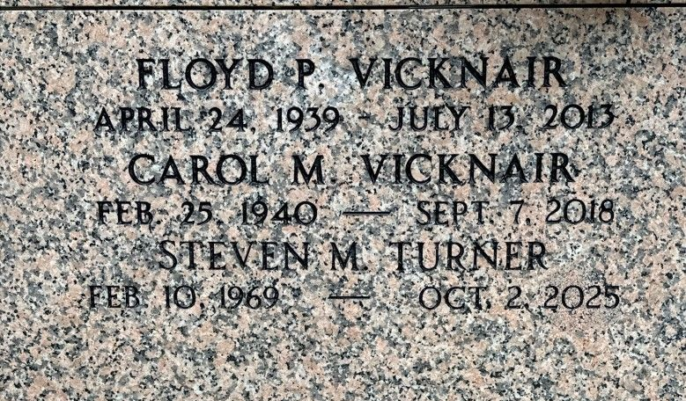
Photo by Team T-Lo

Carol Mehrtens Vicknair passed away on Friday, September 7, 2018. She was 78, born in New Orleans, LA and was a resident of LaPlace, LA. Beloved wife of the late Floyd P. (Floozie) Vicknair. Mother of Matthew and Mark (Jenny) Vicknair, Wanda Wildes (Mardy), Jean Bernuchaux (Ivan), Mary Vicknair, Marie Turner (Steven) and Kerry Penton (Nathan) and the late Floyd Vicknair, Jr. Grandmother of Jessica, Shelby, Adam, Mason, Pierson, Brayden, Connor, Mikayla, Brooke, Bree, Gabriella and Brody. Great-grandmother of Addison and Aven.
Daughter of the late Lillian Toups Mehrtens Scurich and Frederick J. Mehrtens, Sr. Sister of Isabelle (Robert) Murry, Barbara (Henry) Solar, Helen (Gerald) Jacob, Frederick (Lynda) Mehrtens, Jr., John (Patricia) Mehrtens, William (Lynn) Scurich, and Sidney (Cheryl) Scurich. Also survived by many nieces and nephews. She was a Parishioner of St. Joan of Arc Catholic Church in LaPlace and was a charter member of Msgr. Bergeron Knights of Columbus Ladies Auxiliary.
Relatives and friends are invited to the visitation at Millet-Guidry Funeral Home, 2806 W. Airline Hwy, LaPlace, LA on Thursday, September 13, 2018 from 5:00 p.m. until 9:00 p.m. and on Friday, September 14, 2018 from 9:00 a.m. until 10:30 a.m. followed by a Funeral Mass at 11:00 a.m. at St. Joan of Arc Catholic Church, 529 W 5th Street, LaPlace, LA. Interment in St. Peter Cemetery.
Millet-Guidry Funeral Home, LaPlace, Louisiana

