Clotilde (Madere) Vicknair
June 17, 1904 – January 3, 1974

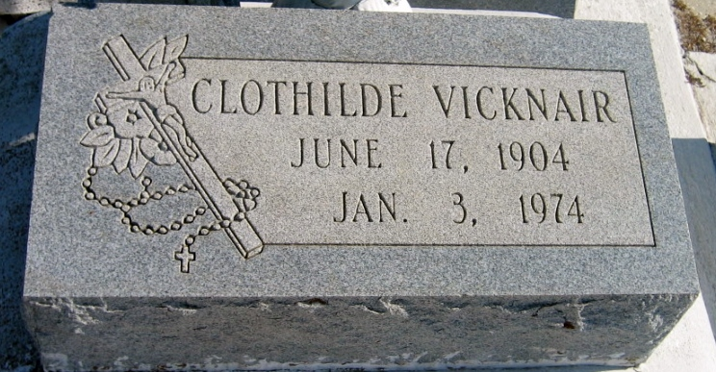
Photo by Bobby

Mrs. Edward Vicknair, of LaPlace, La, on Thursday January 3, 1974, at 10:00 o'clock p.m., wife of the late Edward Vicknair; mother of Harold A. Vicknair of Luling, La, James A. (Tim) Vicknair of LaPlace, La, George V. Vicknair of Baton Rouge, La, Sidney (Don) Vicknair of LaPlace, La, sister of Edwin Madere of Montz, La, Mrs. Elmore Encale of Lutcher, La, Mrs. Evans Keating of LaPlace, La, Miss Madge Madere of Montz, La, Myrtle Madere of New Orleans, La, and the late Lawrence Madere, Andrew Madere and Clement Madere Jr; also survived by 16 grandchildren. Age 69 years.
Relatives and friends of the family, also employees of Monsanto Oil Co and Kaiser Aluminum and Chemical Co, are invited to attend the funeral. Services from the Alexander Funeral Home, 1499 West Fifth St, LaPlace, La, on Saturday, January 5, 1974 at 9:45 o'clock a.m. Religious services at St Joan of Arc Catholic Church, LaPlace, La, at 10:00 o'clock a.m. Interment in St Peter Cemetery, Reserve, La.

The Times-Picayune, New Orleans, Louisiana
January 5, 1974, p. 14

