Congetto (Ferraro) Vicknair
June 13, 1907 – September 11, 1974

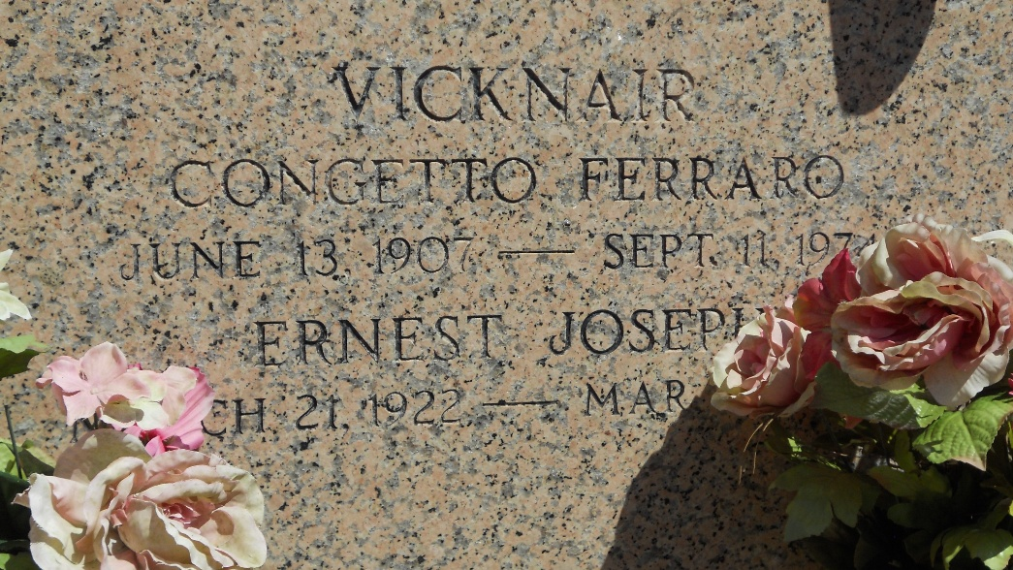
Photo by Team T-Lo

Congetto Ferraro Vicknair, on Wednesday, September 11, 1974; beloved wife of E J Vicknair; mother of Gene Vicknair, of Norco, La; daughter of the late Frances Cali and Nicholas Ferraro; sister of Mrs. Charles (Lucille) Carrona, Carmello Ferraro, Joe Ferraro, Ignazio Ferraro, of Norco, La, Mike Ferraro, of Laplace, La, Mrs. Oliver (Sarah) Alexander, of New Orleans, La, Mrs. Alexis (Ozelia) Aucoin, of Baton Rouge, La.
Relatives and friends of the family, also employees of National Gypsum Co, Shell Oil Co, and Shell Chemical, are invited to attend the funeral. Services from the H C Alexander Funeral Home, Inc, 821 Fourth St, Norco, La, on Friday, September 13, 1974, at 10 o'clock a.m. Recitation of the Rosary by the Holy Name Society Thursday at 7:30 p.m. and by the Ladies Altar Society Friday at 9:15 a.m. Religious services at Sacred Heart Catholic Church. Interment St Peter Mausoleum, Reserve, La.

The Times-Picayune, New Orleans, Louisiana
13 September 1974, p. 14

