Delaune J. Vicknair
March 19, 1913 – October 4, 2002

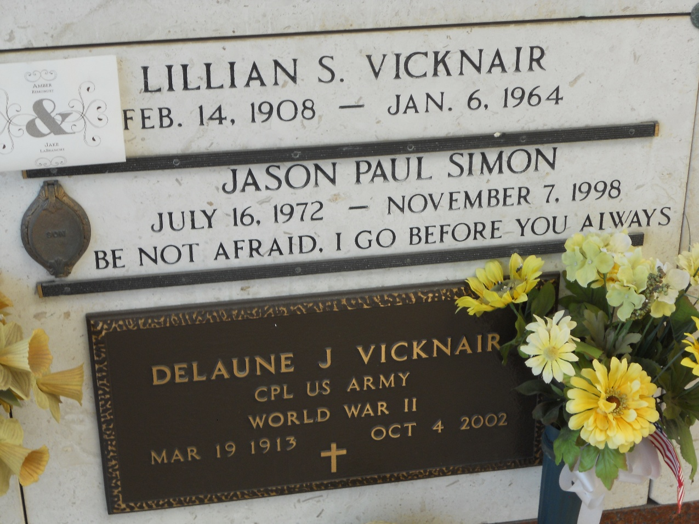
Photo by Team T-Lo

Delaune J. Vicknair On Friday, October 4, 2002 At 5:40 P.M. Beloved Husband Of The Late Lillian Schexnayder Vicknair. Father Of Juanita Simon And Grandfather Of Dawn Brown, Ashley Remondet And The Late Jason Simon. Great-Grandfather Of Amber And Jared Remondet. Brother Of Clara Ancale, Margaret Jouty And Jeanne Hymel. Also The Late Virginia Madere, Jeffery, Ambrose And Henry Vicknair. Age 89. A Native And Resident Of Laplace, La.

The Times-Picayune, New Orleans, Louisiana
October 6, 2002

