Earl Joseph Vicknair
January 22, 1930 – May 4, 2023

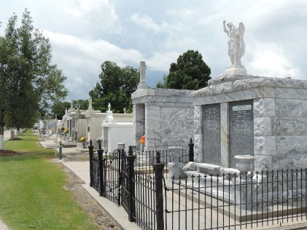

Earl “Boo-Boo” Joseph Vicknair a lifelong resident of Reserve, LA passed away on Thursday May 4, 2023 at the age of 93. Earl was a proud Veteran of the United States Air Force. He voluntarily enlisted the day after his 17th birthday. He often enjoyed sharing stories about the time he spent serving in Panama. After his time in the service, he settled down with the love of his life, became a dad to three beautiful daughters, and eventually retired from Monsanto Chemical Plant in 1985.
Earl was the loving husband of the late Leatrice Vicknair. Beloved dad of Melanie Vicknair (Britt Kennedy), Krissy Vicknair (Dave Preucil), and late Sonya Lulich (Johnny Lulich). Grandfather of Britt Kennedy, Jr, Dustin Kennedy (Karen), John Lulich (Inika), and Jayne Preucil. Great-Grandfather of Tobi, Jayden, Landen, Skylar, and Baylor Kennedy, Mykalah, Tyson and Oaklynn Lulich, Rayleigh and Ronan Radicia. Son of the late Lawrence Vicknair and Lillian Vicknair. Also survived by numerous nieces, nephews, cousins, and friends, and his beloved dog, Reba.
Earl had a laugh that was contagious and always had a smile on his face. He never met a stranger, carried conversations with anyone that would listen, and had the best stories for days. Although he is not with us anymore, his legacy will live on through all of those blessed to have known him.
Relatives and friends are invited to attend the Graveside Service for 11:00 a.m. at St. Peter Catholic Church Cemetery, 1550 Hwy 44, Reserve on Friday, May 12, 2023.
Millet-Guidry Funeral Home, LaPlace, Louisiana

