Edward Vicknair
March 12, 1897 – June 22, 1965

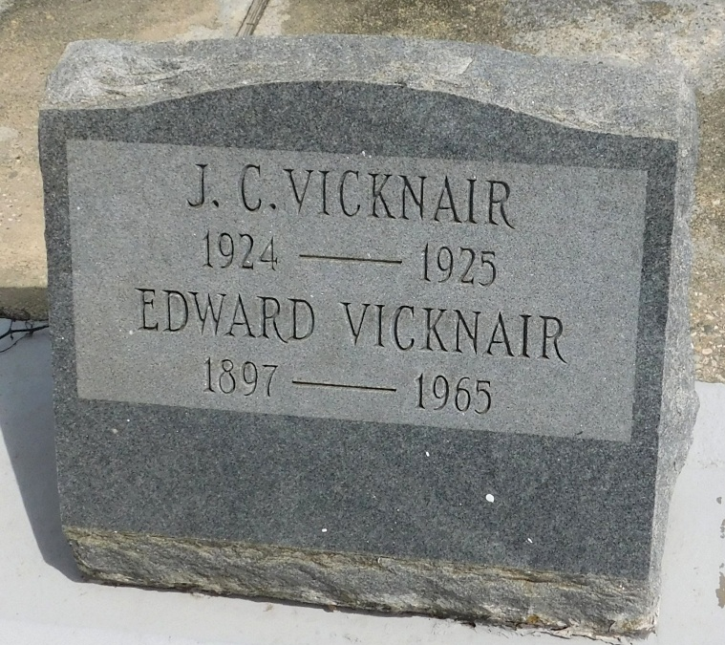
Photo by Mary Agnes Hammett

VICKNAIR - On Tuesday, June 22, 1965, at 3 o'clock p.m., EDWARD VICKNAIR, beloved husband of Clotilde Madere; father of Harold A Vicknair of Luling, La, James A, George V, Sidney D Vicknair, all of Laplace; brother of Willie Vicknair of Gramercy, La, Seymone Vicknair of Laplace, Dennis Vicknair of Chalmette, La, Miss Bee Vicknair of Laplace, and the late Wallace, Theodore Vicknair, Benedette Moreau, Cecile Vicknair, Denise Madere; also survived by 12 grandchildren; age 68 years; a native and resident of Laplace, La.

Relatives and friends of the family are invited to attend the funeral. Services from Millet Funeral Home, Laplace, La, on Thursday, June 24, 1964 (sic), at 9:30 o'clock a.m. Religious services at St Joan of Arc Church, Laplace, La. Interment in St Peter Cemetery, Reserve, La.

The Times-Picayune, New Orleans, Louisiana
24 Jun 1965, p. 6

