Elenore (Jacob) Vicknair
August 13, 1900 – July 24, 1964

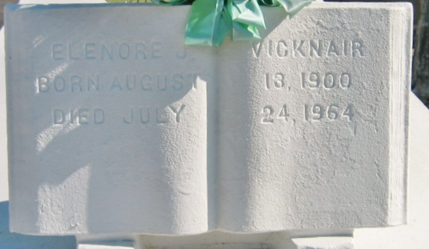
Photo by Bobby

VICKNAIR-On Friday, July 24, 1964, at 12:35 o'clock p.m., ELENORE JACOB, beloved wife of Pierre O. Vicknair; mother of Mrs. Eddie Weber, Mrs. Ernest Scioneaux, Harry and Peter Vicknair of Reserve, La, Mrs. Daniel Maurin and Donald Vicknair of Laplace, La, Clement Vicknair of S. Dakota, and the late Robert Vicknair; sister of Mrs. Nemour Jacob, Mrs. Fred Brown, Mrs. George Templet, Mrs. Wallace Gauthe, Wilson, Theophile, Stanislaus and Wilbert Jacob. Also survived by 22 grandchildren. Age 64 years.

Relatives and friends of the family are invited to attend the funeral. Services from Millet Funeral Home, Reserve, La, on Monday, July 27, 1964, at 9:30 o'clock a.m. Religious services at St Peter Church, Reserve, La, with Mass. Interment in St Peter Cemetery, Reserve, La.

The Times-Picayune, New Orleans, Louisiana
July 26, 1964, p. 14

