Eleonor (Tregre) Vicknair
July 25, 1883 – November 29, 1952

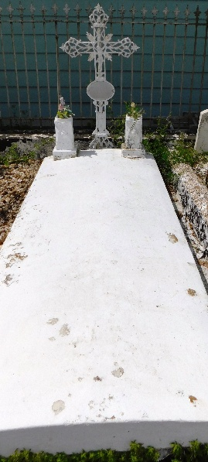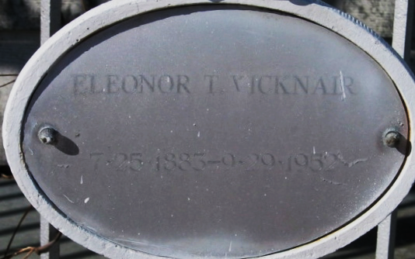
Photos by Mary Agnes Hammett

VICKNAIR - At Charity hospital, New Orleans, on Saturday, November 29, 1952, at 12:15 o'clock a.m., ELNORA TREGRE, wife of the late Norbert Vicknair, mother of Mrs. Vivian Monconduit, New Sarpy, La; Mrs. August Decker, New Orleans; Mrs. Eugene Dupuy, Port Vincent, La, Mrs. Henry Cambre, Mrs. Francis Duhe and Ernest Vicknair, all of Garyville, La, and the late Bentley Vicknair, also survived by 12 grandchildren and four great grandchildren; age 69 years.

Relatives and friends of the family are invited to attend the funeral which will take place from Millet Funeral Home, Reserve, La, on Sunday, November 30, 1952 at 2:30 o'clock p.m., followed by religious services at St Hubert church, Garyville, La. Interment in St Peter cemetery, Reserve, La.

The Times-Picayune, New Orleans, Louisiana
November 30, 1952, p. 12

