Ernestine (Vicknair) Vicknair
March 12, 1875 – February 3, 1902

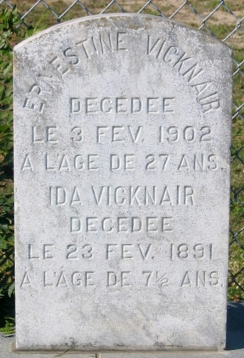
Photo by Bobby

VICKNAIR-Of St. Rose, La., on Sunday, June 27, 1937, at 9:40 o’clock p.m. Ernestine Vicknair, wife of the late George Vicknair; mother of Louis, George and Feleciana Vicknair, Mrs. Albert Decota, Mrs. Rosie Haynes, Mrs. Edna Kinler, Mrs. Orael Sanchez, Mrs. Regina Barbara and Mrs. Marie Oleson; sister of Nicholas and John Marchand; also survived by 16 grandchildren, aged 69 years.

Relatives and friends are invited to attend the funeral from the residence, St. Rose, La., Tuesday morning, June 29, 1937, at 8 o’clock, followed by services at Catholic church, Destrehan, La.

Unknown newspaper clipping

