Euzela (Boudousquie) Vicknair
February 27, 1886 – September 14, 1967

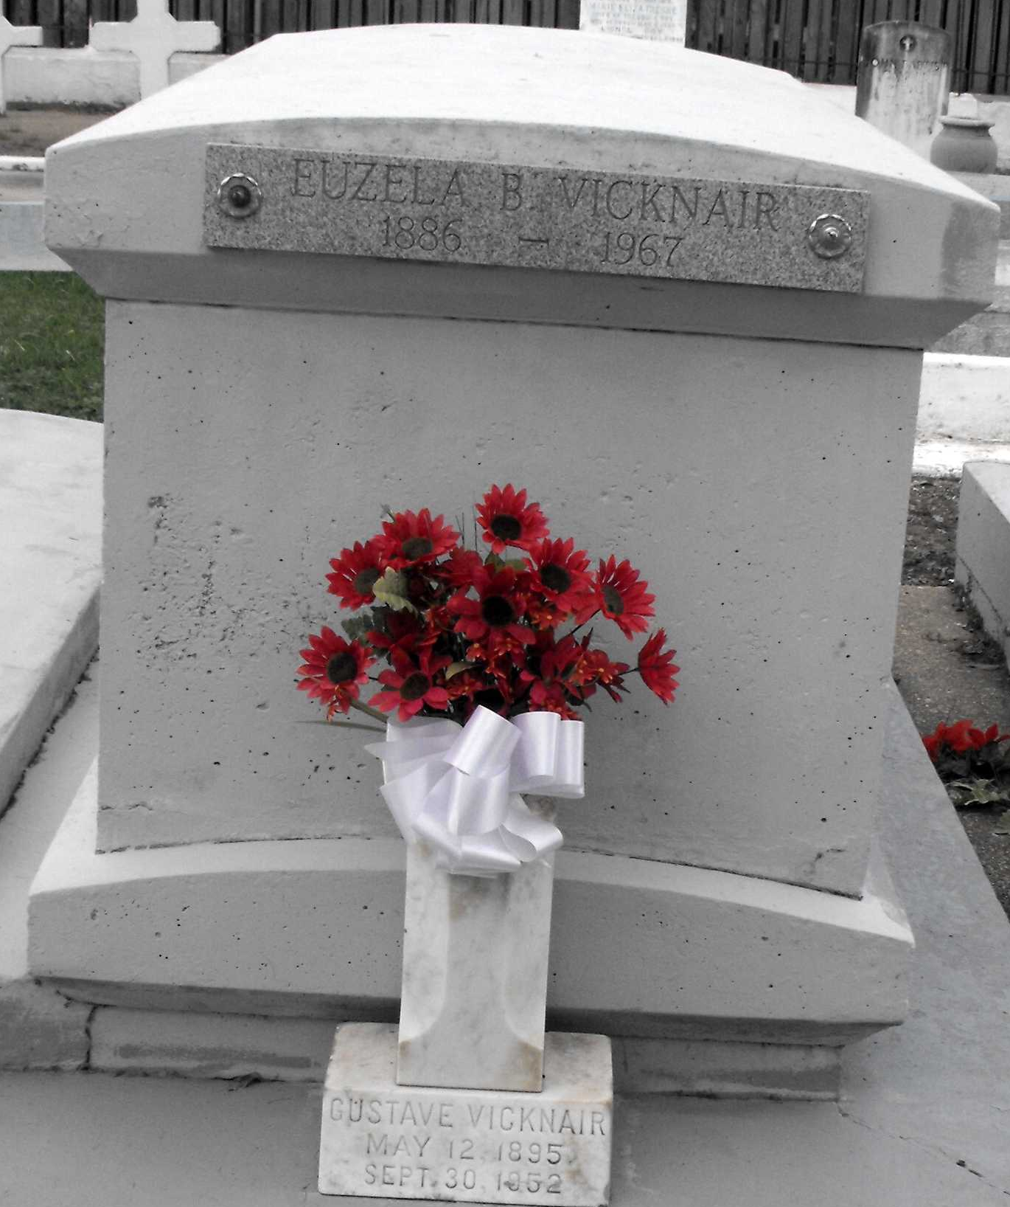
Photo by Mary Agnes Hammett

VICKNAIR - At her residence in Reserve, La, on Thursday, Sept. 14, 1967, at 3:45 o'clock p.m., MRS EUSELA BOUDOUSQUIE VICKNAIR, daughter of the late Marie Brady and Eusebe Boudousquie, wife of the late Amelues Vicknair, mother of Mrs. Paul E. (Thelma) Bourg of Port Arthur, Tex, Mrs. Leo J. (Beatrice) Lasseigne, Francis J. Vicknair, Mrs. Dasise J. (Hilda) Labat and Mrs. Eddie F. (Edna Mae) Montz, all of Reserve, La, also survived by 13 grandchild-ren and 12 great grandchildren; age 81 years 7 months.
Relatives and friends of the family are invited to attend the funeral. Services from Millet Funeral Home, Reserve, La, on Friday morning, Sept. 15, 1967, at 9:30 o'clock a.m.; religious services at St Peter's Church, Reserve, La. Interment St Peter's Cemetery.
The Times-Picayune, New Orleans, Louisiana
15 Sep 1967, p. 2

