Felicie (Vicknair) Vicknair
July 4, 1868 – December 20, 1950

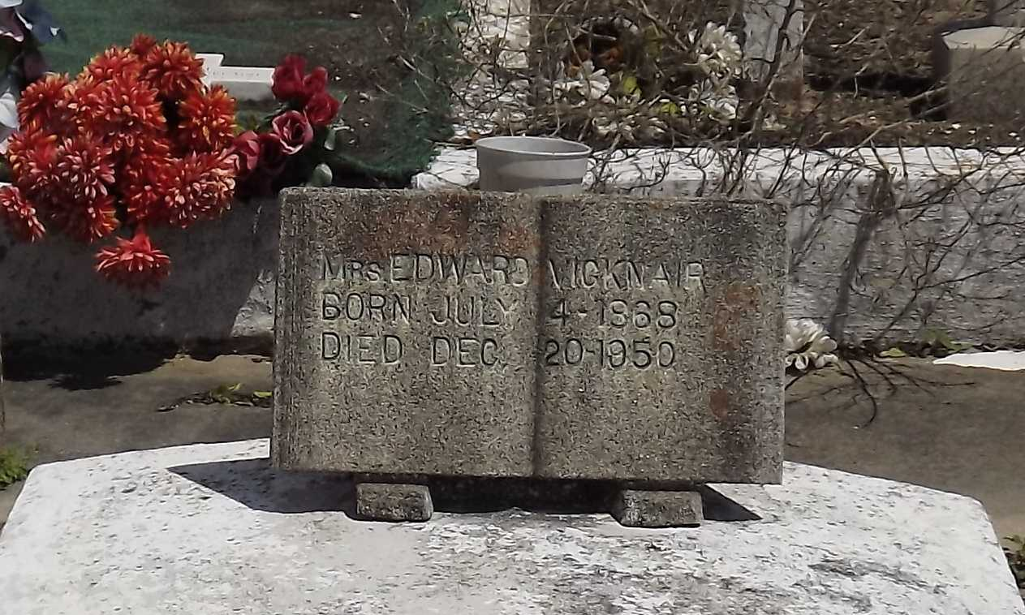
Photo by Mary Agnes Hammett

VICKNAIR-On Wednesday, December 20, 1950, at 7:15 o'clock p.m., FELICIE VICKNAIR, wife of the late Edward Vicknair; mother of Mrs. Norbert Madere, Cecile, Wallace, Edward, Theodore, Beatrice, Dennis, Simon and Willie Vicknair: aged 83 years.

Relatives and friends of the family are invited to attend the funeral which will take place from Millet's Funeral Home, Reserve, LA, on Friday, December 22, 1950 at 8:30 o'clock a.m., followed by religious services at St Joan of Arc Church, Laplace, LA, at 9 o'clock. Interment in St Peter's Cemetery, Reserve, LA.
The Times-Picayune, New Orleans, Louisiana
22 Dec 1950, p. 2

