Floyd Paul Vicknair
April 24, 1939 – July 13, 2013

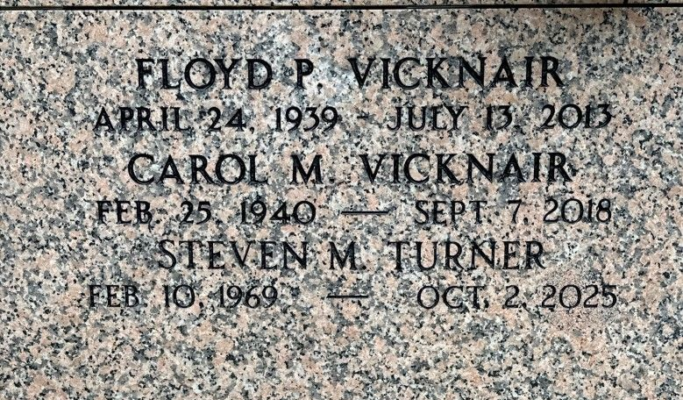
Photo by Team T-Lo

Floyd P. (Floozie) Vicknair died on Saturday July 13, 2013 at the age of 74.

Beloved husband of Carol Mehrtens Vicknair. Father of Matthew and Mark (Jenny) Vicknair, Wanda Wildes (Mardy), Jean Bernuchaux (Ivan), Mary Vicknair, Marie Turner (Steven)and Kerry Penton (Nathan) and the late Floyd Vicknair Jr. Grandfather of Jessica, Shelby, Adam, Mason, Pierson, Brayden, Connor, Mikayla, Brooke, Bree , Gabriella and Brody. Great-grandfather of Addison. Son of the late Frank Jr., and Pauline LaBranche Vicknair. Brother of Gary and Gerald Vicknair, Gladys Elfer, and the late Kenneth, Frank Vicknair III and Geraldine Curley.
He was a life member of Msgr. Dennis Bergeron Knights of Columbus, Council 5935, board member of St. John Farm Bureau and parishioner of St. Joan of Arc Catholic Church. A native and resident of LaPlace.
Relatives and friends are invited to attend services. Visitation at Millet-Guidry Funeral Home, LaPlace, LA, on Thursday July 18, 2013 from 5:00pm to 9:00pm and on Friday from 9:00am to 10:30am, followed by Mass at 11:00am at St. Peter Catholic Church, Reserve, LA. Burial in St. Peter Cemetery, Reserve, LA.

The Times-Picayune, New Orleans, Louisiana
July 15 to July 17, 2013

